IBM NAAN MUDHALVAN

Applied Data Science

Project: Credit card fraud detection

Problem Definition:

Design thinking is a human-centered approach to problem-solving that can be applied to various domains, including credit card fraud detection. When using design thinking to tackle the problem of credit card fraud, it's important to focus on both the technical and user aspects of the solution.

1. Understand the Problem: Begin by thoroughly understanding the issue of credit card fraud. Gather data on the current state of fraud, the common fraud patterns, and the impact on customers and businesses.

2. Define the Problem Statement: Clearly define the problem statement. For example, "How might we improve credit card fraud detection to reduce false positives and enhance the user experience?"

3. Identify Stakeholders: Identify the key stakeholders involved, including customers, financial institutions, and fraud analysts. Understand their perspectives and needs.

Design Thinking:

1. Empathize (Understand the User): Conduct interviews, surveys, or observations to understand the pain points and concerns of customers who have experienced false positives or fraudulent transactions. Empathize with fraud analysts and understand their challenges in managing fraud detection systems.

2. Define (Frame the Problem): Summarize the insights from your research to create a user persona or journey map to represent the user's perspective. Clearly define the problem, considering both technical and user aspects. For example, the problem might be framed as improving the accuracy of fraud detection while minimizing disruptions for legitimate customers.

3. Ideate (Generate Ideas): Brainstorm ideas and solutions with a cross-functional team that includes engineers, data scientists, designers, and business analysts. Explore various technical approaches, such as machine learning algorithms, anomaly detection techniques, and rule-based systems. Consider user-centric ideas, such as real-time notifications, user-friendly interfaces, and personalized fraud alerts.

4. Prototype (Create Solutions): Create prototypes of potential solutions. For the technical aspect, this might involve developing and testing machine learning models. For the user aspect, create wireframes or mockups of user interfaces.

5. Test (Gather Feedback): Collect feedback from users and stakeholders on both the technical and user-centric solutions. Iterate on the prototypes based on feedback, making necessary adjustments to improve the system's effectiveness and user experience.

6. Implement (Deliver the Solution): Develop the final solution based on the refined prototypes and feedback. Implement the machine learning models, user interfaces, and any other components necessary for credit card fraud detection. Integrate the solution into the existing infrastructure of financial institutions.

7. Evaluate (Measure Impact): Continuously monitor the performance of the fraud detection system, tracking metrics such as false positives, false negatives, and user satisfaction. Make ongoing improvements to the system based on the measured impact and evolving fraud patterns.

Credit card fraud is any dishonest act and behaviour to obtain information without the proper authorization from the account holder for financial gain. Among different ways of frauds, Skimming is the most common one, which is the way of duplicating of information located on the magnetic strip of the card. Apart from this, the other ways are:

Manipulation/alteration of genuine cards

Creation of counterfeit cards

Stolen/lost credit cards

Fraudulent telemarketing

Data Understanding: Here, we need to load the data and understand the features present in it. This would help us choose the features that we will need for your final model.

Exploratory data analytics (EDA): Normally, in this step, we need to perform univariate and bivariate analyses of the data, followed by feature transformations, if necessary. For the current data set, because Gaussian variables are used, we do not need to perform Z-scaling. However, you can check if there is any skew-ness in the data and try to mitigate it, as it might cause problems during the model-building phase.

Train/Test Split: Now we are familiar with the train/test split, which we can perform in order to check the performance of our models with unseen data. Here, for validation, we can use the k-fold cross-validation method. We need to choose an appropriate k value so that the minority class is correctly represented in the test folds.

Model-Building/ hyper-parameter Tuning: This is the final step at which we can try different models and fine-tune their hyper-parameters until we get the desired level of performance on the given dataset. We should try and see if we get a better model by the various sampling techniques.

Model Evaluation: We need to evaluate the models using appropriate evaluation metrics. Note that since the data is imbalanced it is more important to identify which are fraudulent transactions accurately than the non-fraudulent. We need to choose an appropriate evaluation metric which reflects this business goal.

Source code

import pandas as pd

import numpy as np

import matplotlib.pyplot as plt

% matplotlib inline

import seaborn as sns

import warnings

warnings.filterwarnings('ignore')

pd.set option('display.max_columns', 500)

*# Reading the dataset*

df **=** pd**.**read_csv('creditcard.csv')

df**.**head()

df**.**shape

df**.**info()

df**.**describe()

*# Cheking percent of missing values in columns*

df_missing_columns **=** (round(((df**.**isnull()**.**sum()**/**len(df**.**index))**\***100),2)**.**to_frame('null'))**.**sort_values('null', ascending**=False**)

df_missing_columns

**Checking the distribution of the classes**

classes **=** df['Class']**.**value_counts()

classes

normal_share **=** round((classes[0]**/**df['Class']**.**count()**\***100),2)

normal_share

fraud_share **=** round((classes[1]**/**df['Class']**.**count()**\***100),2)

fraud_share

The dataset can be download using this: https://www.kaggle.com/mlg-ulb/creditcardfraud

*# Bar plot for the number of fraudulent vs non-fraudulent transcations*

sns**.**countplot(x**=**'Class', data**=**df)

plt**.**title('Number of fraudulent vs non-fraudulent transcations')

plt**.**show()

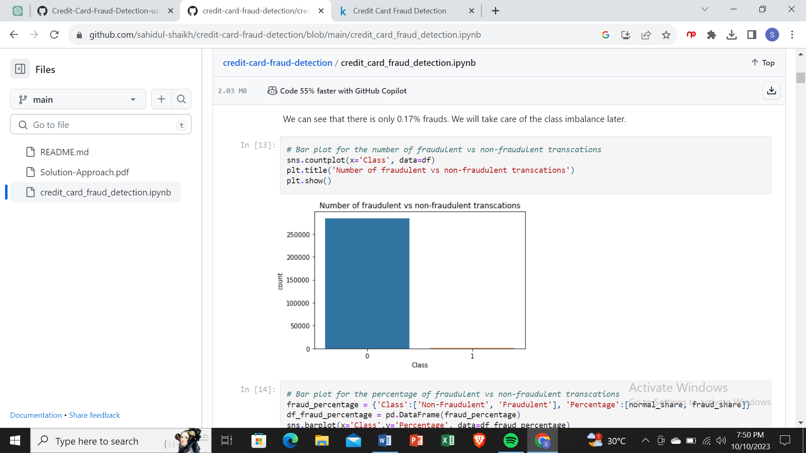

*# Bar plot for the percentage of fraudulent vs non-fraudulent transcations*

fraud_percentage **=** {'Class':['Non-Fraudulent', 'Fraudulent'], 'Percentage':[normal_share, fraud_share]}

df_fraud_percentage **=** pd**.**DataFrame(fraud_percentage)

sns**.**barplot(x**=**'Class',y**=**'Percentage', data**=**df_fraud_percentage)

plt**.**title('Percentage of fraudulent vs non-fraudulent transcations')

plt**.**show()

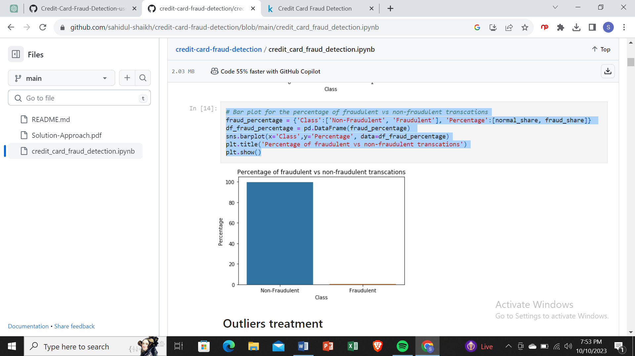

# Creating fraudulent dataframe

data_fraud = df[df['Class'] == 1]

# Creating non fraudulent dataframe

data_non_fraud = df[df['Class'] == 0]

# Distribution plot

plt.figure(figsize=(8,5))

ax = sns.distplot(data_fraud['Time'],label='fraudulent',hist=False)

ax = sns.distplot(data_non_fraud['Time'],label='non fraudulent',hist=False)

ax.set(xlabel='Seconds elapsed between the transction and the first transction')

plt.show()

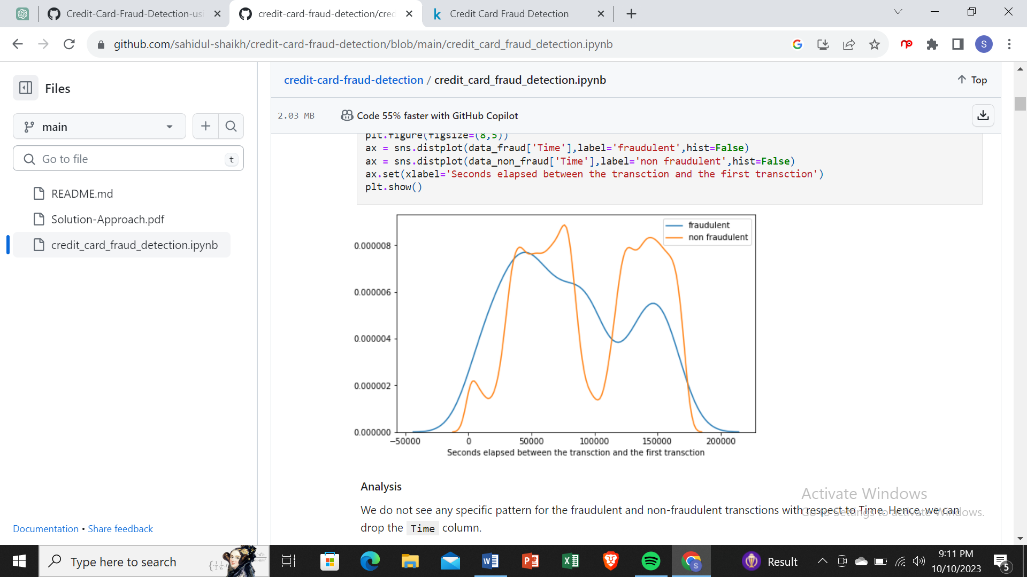

Analysis

We do not see any specific pattern for the fraudulent and non-fraudulent transctions with respect to Time. Hence, we can drop the Time column.

# Dropping the Time column

df.drop('Time', axis=1, inplace=True)

Observe the distribution of classes with amount

# Distribution plot

plt.figure(figsize=(8,5))

ax = sns.distplot(data_fraud['Amount'],label='fraudulent',hist=False)

ax = sns.distplot(data_non_fraud['Time'],label='non fraudulent',hist=False)

ax.set(xlabel='Transction Amount')

plt.show()

Analysis

We can see that the fraudulent transactions are mostly dense in the lower range of amount, whereas the non-fraudulent transactions are spreaded throughout low to high range of amount.

# Model building on imbalanced data

### Metric selection for heavily imbalanced data

As we have seen that the data is heavily imbalanced, where only 0.17% transaction are fraudulent, we should not consider Accuracy as a good measure for evaluating the model. Because in the case of all the data points return a particular class (1/0) irrespective of any prediction, still the model will result more than 99% Accuracy.

Hence, we have to measure the ROC-AUC score for fair evaluation of the model. The ROC curve is used to understand the strength of the model by evaluating the performance of the model at all the classification thresholds. The default threshold of 0.5 is not always the ideal threshold to find the best classification label of the test point. Because the ROC curve is measured at all thresholds, the best threshold would be one at which the TPR is high and FPR is low, i.e., misclassifications are low. After determining the optimal threshold, we can calculate the F1 score of the classifier to measure the precision and recall at the selected threshold.

#### Why SVM was not tried for model building and Random Forest was not tried for few cases?

In the dataset we have 284807 data points and in the case of Oversampling we would have even more number of data points. SVM is not very efficient with large number of data points because it takes lot of computational power and resources to make the transformation. When we perform the cross validation with K-Fold for hyper-parameter tuning, it takes lot of computational resources and it is very time consuming. Hence, because of the unavailability of the required resources and time SVM was not tried.

For the same reason Random forest was also not tried for model building in few of the hyper-parameter tuning for oversampling technique.

#### Why KNN was not used for model building?

KNN is not memory efficient. It becomes very slow as the number of data points increases as the model needs to store all the data points. It is computationally heavy because for a single data point the algorithm has to calculate the distance of all the data points and find the nearest neighbors.

### Logistic regression

*# Importing scikit logistic regression module*

**from** sklearn. Linear _ model **import** Logistic Regression

*# Importing metrics*

**from** sklearn **import** metrics

**from** sklearn.metrics **import** confusion_matrix

**from** sklearn.metrics **import** f1_score

**from** sklearn.metrics **import** classification_report

#### Tuning hyperparameter C

C is the the inverse of regularization strength in Logistic Regression. Higher values of C correspond to less regularization.

*# Importing libraries for cross validation*

**from** sklearn.model_selection **import** KFold

**from** sklearn.model_selection **import** cross_val_score

**from** sklearn.model_selection **import** GridSearchCV

*# Creating KFold object with 5 splits*

folds **=** KFold(n_splits**=**5, shuffle**=True**, random_state**=**4)

*# Specify params*

params **=** {"C": [0.01, 0.1, 1, 10, 100, 1000]}

*# Specifing score as recall as we are more focused on acheiving the higher sensitivity than the accuracy*

model_cv **=** GridSearchCV(estimator **=** LogisticRegression(),

param_grid **=** params,

scoring**=** 'roc_auc',

cv **=** folds,

verbose **=** 1,

return_train_score**=True**)

*# Fit the model*

model_cv**.**fit(X_train, y_train)

Fitting 5 folds for each of 6 candidates, totalling 30 fits

[Parallel(n_jobs=1)]: Using backend SequentialBackend with 1 concurrent workers.

[Parallel(n_jobs=1)]: Done 30 out of 30 | elapsed: 43.0s finished

GridSearchCV(cv=KFold(n_splits=5, random_state=4, shuffle=True),

error_score=nan,

estimator=LogisticRegression(C=1.0, class_weight=None, dual=False,

fit_intercept=True,

intercept_scaling=1, l1_ratio=None,

max_iter=100, multi_class='auto',

n_jobs=None, penalty='l2',

random_state=None, solver='lbfgs',

tol=0.0001, verbose=0,

warm_start=False),

iid='deprecated', n_jobs=None,

param_grid={'C': [0.01, 0.1, 1, 10, 100, 1000]},

pre_dispatch='2*n_jobs', refit=True, return_train_score=True,

scoring='roc_auc', verbose=1)

cv_results **=** pd**.**DataFrame(model_cv**.**cv_results

|  |  |  |  |  |  |  |  |  |  |  |  |  |  |  |  |  |  |  |  |  |  |
| --- | --- | --- | --- | --- | --- | --- | --- | --- | --- | --- | --- | --- | --- | --- | --- | --- | --- | --- | --- | --- | --- |
|  |  |  |  |  |  |  |  |  |  |  |  |  |  |  |  |  |  |  |  |  |  |
|  |  |  |  |  |  |  |  |  |  |  |  |  |  |  |  |  |  |  |  |  |  |
|  |  |  |  |  |  |  |  |  |  |  |  |  |  |  |  |  |  |  |  |  |  |
|  |  |  |  |  |  |  |  |  |  |  |  |  |  |  |  |  |  |  |  |  |  |
|  |  |  |  |  |  |  |  |  |  |  |  |  |  |  |  |  |  |  |  |  |  |
|  |  |  |  |  |  |  |  |  |  |  |  |  |  |  |  |  |  |  |  |  |  |

lt**.**figur

e(figsize**=**(8, 6))

plt**.**plot(cv_results['param_C'], cv_results['mean_test_score'])

plt**.**plot(cv_results['param_C'], cv_results['mean_train_score'])

plt**.**xlabel('C')

plt**.**ylabel('roc_auc')

plt**.**legend(['test result', 'train result'], loc**=**'upper left')

plt**.**xscale('log')

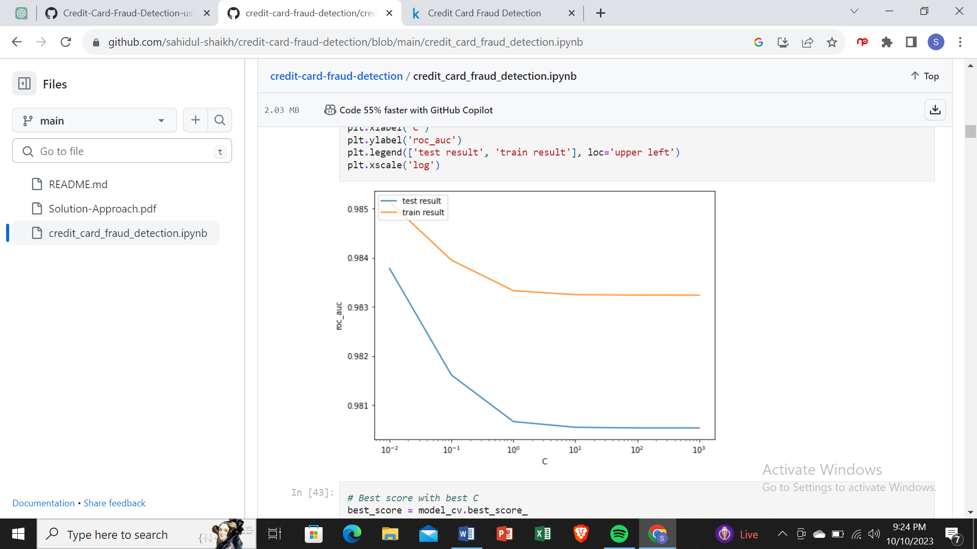

# Best score with best C

best_score = model_cv.best_score_

best_C = model_cv.best_params_['C']

print(" The highest test roc_auc is {0} at C = {1}".format(best_score, best_C))

The highest test roc_auc is 0.9837811907775487 at C = 0.01

Logistic regression with optimal C

# Instantiate the model with best C

logistic_imb = LogisticRegression(C=0.01)

# Fit the model on the train set

logistic_imb_model = logistic_imb.fit(X_train, y_train)

Prediction on the train set

# Predictions on the train set

y_train_pred = logistic_imb_model.predict(X_train)

# Confusion matrix

confusion = metrics.confusion_matrix(y_train, y_train_pred)

print(confusion)

[[227427 22]

[ 135 261]]

TP = confusion[1,1] # true positive

TN = confusion[0,0] # true negatives

FP = confusion[0,1] # false positives

FN = confusion[1,0] # false negatives

# Accuracy

print("Accuracy:-",metrics.accuracy_score(y_train, y_train_pred))

# Sensitivity

print("Sensitivity:-",TP / float(TP+FN))

# Specificity

print("Specificity:-", TN / float(TN+FP))

# F1 score

print("F1-Score:-", f1_score(y_train, y_train_pred))

Accuracy:- 0.9993109350655051

Sensitivity:- 0.6590909090909091

Specificity:- 0.9999032750198946

F1-Score:- 0.7687776141384388

# classification_report

print(classification_report(y_train, y_train_pred))

precision recall f1-score support

0 1.00 1.00 1.00 227449

1 0.92 0.66 0.77 396

accuracy 1.00 227845

macro avg 0.96 0.83 0.88 227845

weighted avg 1.00 1.00 1.00 227845

ROC on the train set

# ROC Curve function

def draw_roc( actual, probs ):

fpr, tpr, thresholds = metrics.roc_curve( actual, probs,

drop_intermediate = False )

auc_score = metrics.roc_auc_score( actual, probs )

plt.figure(figsize=(5, 5))

plt.plot( fpr, tpr, label='ROC curve (area = %0.2f)' % auc_score )

plt.plot([0, 1], [0, 1], 'k--')

plt.xlim([0.0, 1.0])

plt.ylim([0.0, 1.05])

plt.xlabel('False Positive Rate or [1 - True Negative Rate]')

plt.ylabel('True Positive Rate')

plt.title('Receiver operating characteristic example')

plt.legend(loc="lower right")

plt.show()

return None

# Predicted probability

y_train_pred_proba = logistic_imb_model.predict_proba(X_train)[:,1]

# Plot the ROC curve

draw_roc(y_train, y_train_pred_proba)

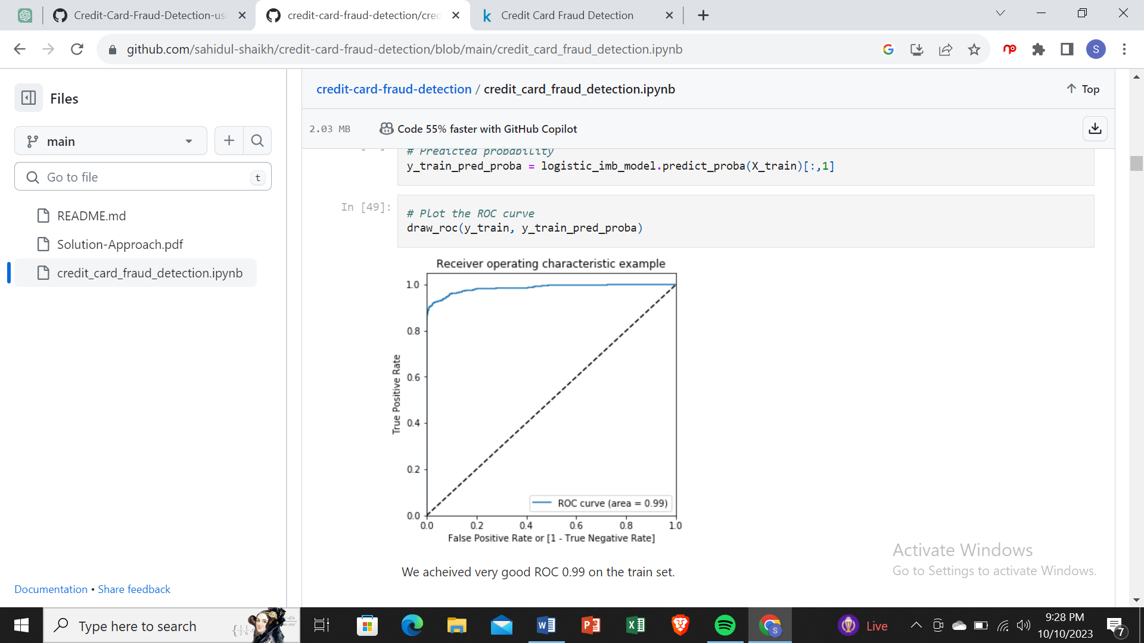

Prediction on the test set

# Prediction on the test set

y_test_pred = logistic_imb_model.predict(X_test)

# Confusion matrix

confusion = metrics.confusion_matrix(y_test, y_test_pred)

print(confusion)

[[56850 16]

[ 42 54]]

TP = confusion[1,1] # true positive

TN = confusion[0,0] # true negatives

FP = confusion[0,1] # false positives

FN = confusion[1,0] # false negatives

# Accuracy

print("Accuracy:-",metrics.accuracy_score(y_test, y_test_pred))

# Sensitivity

print("Sensitivity:-",TP / float(TP+FN))

# Specificity

print("Specificity:-", TN / float(TN+FP))

# F1 score

print("F1-Score:-", f1_score(y_test, y_test_pred))

Accuracy:- 0.9989817773252344

Sensitivity:- 0.5625

Specificity:- 0.9997186367952731

F1-Score:- 0.6506024096385543

# classification_report

print(classification_report(y_test, y_test_pred))

*# classification_report*

print(classification_report(y_test, y_test_pred))

precision recall f1-score support

0 1.00 1.00 1.00 56866

1 0.77 0.56 0.65 96

accuracy 1.00 56962

macro avg 0.89 0.78 0.83 56962

weighted avg 1.00 1.00 1.00 56962

ROC on the test set

# Predicted probability

y_test_pred_proba = logistic_imb_model.predict_proba(X_test)[:,1]

# Plot the ROC curve

draw_roc(y_test, y_test_pred_proba)

We can see that we have very good ROC on the test set 0.97, which is almost close to 1.

*Model summary*

Train set

Accuracy = 0.99

Sensitivity = 0.70

Specificity = 0.99

F1-Score = 0.76

ROC = 0.99

Test set

Accuracy = 0.99

Sensitivity = 0.77

Specificity = 0.99

F1-Score = 0.65

ROC = 0.97

Overall, the model is performing well in the test set, what it had learnt from the train set.

XGBoost

# Importing XGBoost

from xgboost import XGBClassifier

Tuning the hyperparameters

# hyperparameter tuning with XGBoost

# creating a KFold object

folds = 3

# specify range of hyperparameters

param_grid = {'learning_rate': [0.2, 0.6],

'subsample': [0.3, 0.6, 0.9]}

# specify model

xgb_model = XGBClassifier(max_depth=2, n_estimators=200)

# set up GridSearchCV()

model_cv = GridSearchCV(estimator = xgb_model,

param_grid = param_grid,

scoring= 'roc_auc',

cv = folds,

verbose = 1,

return_train_score=True)

# fit the model

model_cv.fit(X_train, y_train)

Fitting 3 folds for each of 6 candidates, totalling 18 fits

[Parallel(n_jobs=1)]: Using backend SequentialBackend with 1 concurrent workers.

[Parallel(n_jobs=1)]: Done 18 out of 18 | elapsed: 12.6min finished

GridSearchCV(cv=3, error_score=nan,

estimator=XGBClassifier(base_score=0.5, booster='gbtree',

colsample_bylevel=1, colsample_bynode=1,

colsample_bytree=1, gamma=0,

learning_rate=0.1, max_delta_step=0,

max_depth=2, min_child_weight=1,

missing=None, n_estimators=200, n_jobs

nthread=None, objective='binary:logistic

random_state=0,reg_alpha=0,reg_lambda=1,

scale_pos_weight=1, seed=None, silentne,

subsample=1, verbosity=1),

iid='deprecated', n_jobs=None,

param_grid={'learning_rate': [0.2, 0.6],

'subsample': [0.3, 0.6, 0.9]},

pre_dispatch='2*n_jobs', refit=True, return_train_score=True,

scoring='roc_auc', verbose=1)

# cv results

cv_results = pd.DataFrame(model_cv.cv_results_)

cv_results

…………………..

# # plotting

plt.figure(figsize=(16,6))

param_grid = {'learning_rate': [0.2, 0.6],

'subsample': [0.3, 0.6, 0.9]}

for n, subsample in enumerate(param_grid['subsample']):

# subplot 1/n

plt.subplot(1,len(param_grid['subsample']), n+1)

df = cv_results[cv_results['param_subsample']==subsample]

plt.plot(df["param_learning_rate"], df["mean_test_score"])

plt.plot(df["param_learning_rate"], df["mean_train_score"])

plt.xlabel('learning_rate')

plt.ylabel('AUC')

plt.title("subsample={0}".format(subsample))

plt.ylim([0.60, 1])

plt.legend(['test score', 'train score'], loc='upper left')

plt.xscale('log')

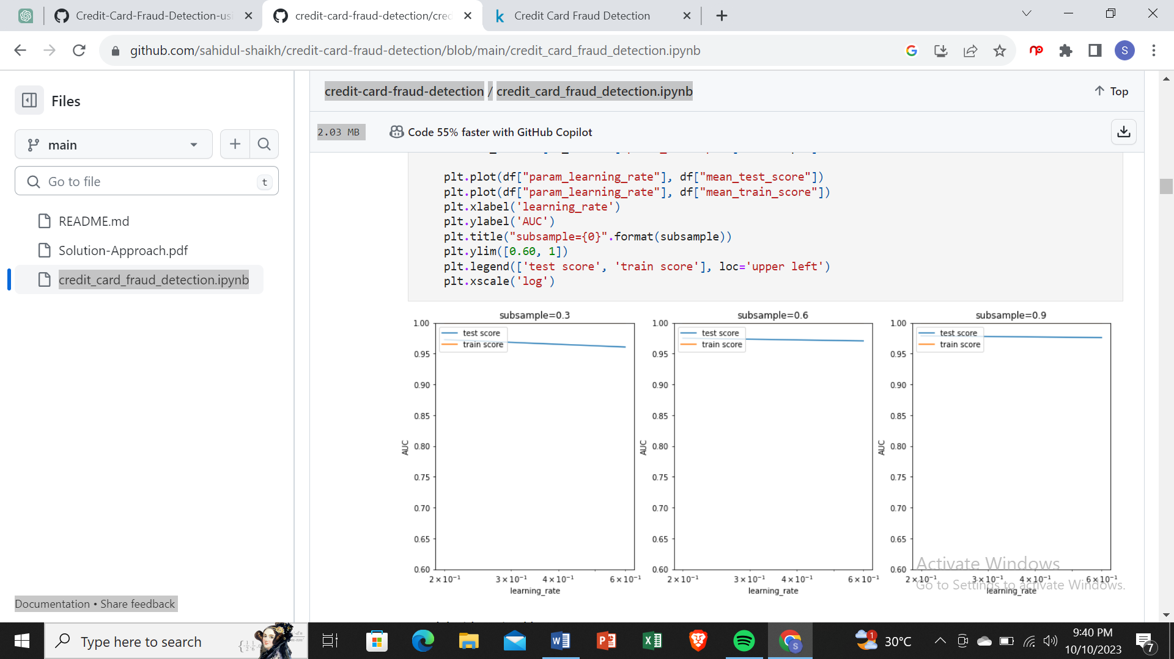

Model with optimal hyperparameters

We see that the train score almost touches to 1. Among the hyperparameters, we can choose the best parameters as learning_rate : 0.2 and subsample: 0.3

model_cv.best_params_

{'learning_rate': 0.2, 'subsample': 0.9}

# chosen hyperparameters

# 'objective':'binary:logistic' outputs probability rather than label, which we need for calculating auc

params = {'learning_rate': 0.2,

'max_depth': 2,

'n_estimators':200,

'subsample':0.9,

'objective':'binary:logistic'}

# fit model on training data

xgb_imb_model = XGBClassifier(params = params)

xgb_imb_model.fit(X_train, y_train)

XGBClassifier(base_score=0.5, booster=None, colsample_bylevel=1,

colsample_bynode=1, colsample_bytree=1, gamma=0, gpu_id=-1,

importance_type='gain', interaction_constraints=None,

learning_rate=0.300000012, max_delta_step=0, max_depth=6,

min_child_weight=1, missing=nan, monotone_constraints=None,

n_estimators=100, n_jobs=0, num_parallel_tree=1,

objective='binary:logistic',

params={'learning_rate': 0.2, 'max_depth': 2, 'n_estimators': 200,

'objective': 'binary:logistic', 'subsample': 0.9},

random_state=0, reg_alpha=0, reg_lambda=1, scale_pos_weight=1,

subsample=1, tree_method=None, validate_parameters=False,

verbosity=None)

Prediction on the train set

# Predictions on the train set

y_train_pred = xgb_imb_model.predict(X_train)

# Confusion matrix

confusion = metrics.confusion_matrix(y_train, y_train_pred)

print(confusion)

[[227449 0]

[ 0 396]]

TP = confusion[1,1] # true positive

TN = confusion[0,0] # true negatives

FP = confusion[0,1] # false positives

FN = confusion[1,0] # false negatives

# Accuracy

print("Accuracy:-",metrics.accuracy_score(y_train, y_train_pred))

# Sensitivity

print("Sensitivity:-",TP / float(TP+FN))

# Specificity

print("Specificity:-", TN / float(TN+FP))

# F1 score

print("F1-Score:-", f1_score(y_train, y_train_pred))

Accuracy:- 1.0

Sensitivity:- 1.0

Specificity:- 1.0

F1-Score:- 1.0

# classification_report

print(classification_report(y_train, y_train_pred))

precision recall f1-score support

0 1.00 1.00 1.00 227449

1 1.00 1.00 1.00 396

accuracy 1.00 227845

macro avg 1.00 1.00 1.00 227845

weighted avg 1.00 1.00 1.00 227845

# Predicted probability

y_train_pred_proba_imb_xgb = xgb_imb_model.predict_proba(X_train)[:,1]

# roc_auc

auc = metrics.roc_auc_score(y_train, y_train_pred_proba_imb_xgb)

auc

1.0

# Plot the ROC curve

draw_roc(y_train, y_train_pred_proba_imb_xgb)

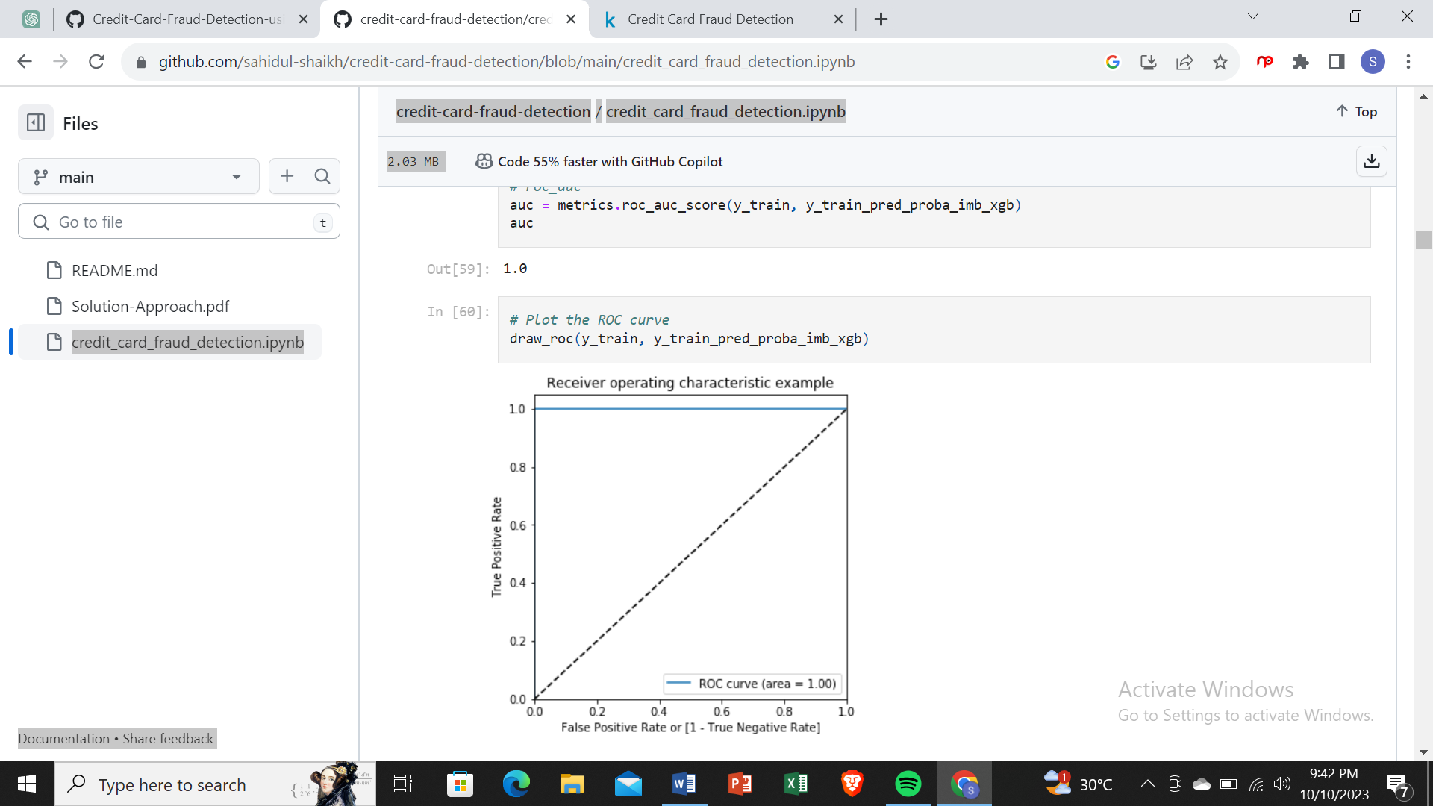

Prediction on the test set

# Predictions on the test set

y_test_pred = rfc_imb_model.predict(X_test)

# Confusion matrix

confusion = metrics.confusion_matrix(y_test, y_test_pred)

print(confusion)

[[56841 25]

[ 36 60]]

TP = confusion[1,1] # true positive

TN = confusion[0,0] # true negatives

FP = confusion[0,1] # false positives

FN = confusion[1,0] # false negatives

# Accuracy

print("Accuracy:-",metrics.accuracy_score(y_test, y_test_pred))

# Sensitivity

print("Sensitivity:-",TP / float(TP+FN))

# Specificity

print("Specificity:-", TN / float(TN+FP))

# F1 score

print("F1-Score:-", f1_score(y_train, y_train_pred))

Accuracy:- 0.9989291106351603

Sensitivity:- 0.625

Specificity:- 0.9995603699926142

F1-Score:- 0.7983761840324763

# classification_report

print(classification_report(y_test, y_test_pred))

precision recall f1-score support

0 1.00 1.00 1.00 56866

1 0.71 0.62 0.66 96

accuracy 1.00 56962

macro avg 0.85 0.81 0.83 56962

weighted avg 1.00 1.00 1.00 56962

# Predicted probability

y_test_pred_proba = rfc_imb_model.predict_proba(X_test)[:,1]

# roc_auc

auc = metrics.roc_auc_score(y_test, y_test_pred_proba)

auc

0.9474696179029063

# Plot the ROC curve

draw_roc(y_test, y_test_pred_proba)

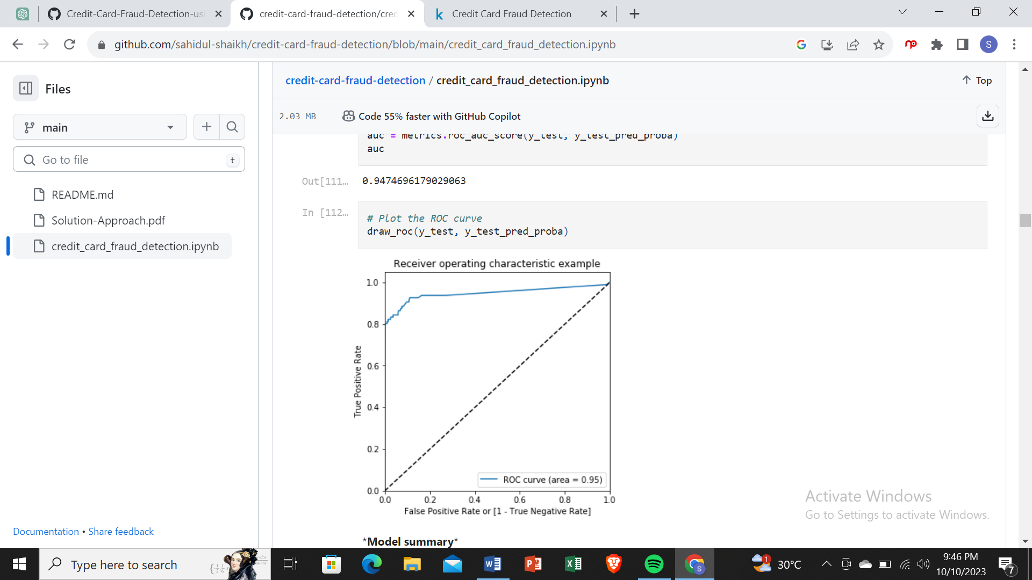

*Model summary*

Train set

Accuracy = 0.99

Sensitivity = 1.0

Specificity = 1.0

F1-Score = 0.80

ROC-AUC = 0.98

Test set

Accuracy = 0.99

Sensitivity = 0.62

Specificity = 0.99

F-1 Score = 0.75

ROC-AUC = 0.96

Choosing best model on the imbalanced data

We can see that among all the models we tried (Logistic, XG-Boost, Decision Tree, and Random Forest), almost all of them have performed well. More specifically logistic regression and XG-Boost performed best in terms of ROC-AUC score.

But as we have to choose one of them, we can go for the best as XG-Boost, which gives us ROC score of 1.0 on the train data and 0.98 on the test data.

Keep in mind that XG-Boost requires more resource utilization than Logistic model. Hence building XG-Boost model is more costly than the Logistic model. But XG-Boost having ROC score 0.98, which is 0.01 more than the Logistic model. The 0.01 increase of score may convert into huge amount of saving for the bank.

Print the important features of the best model to understand the dataset

This will not give much explanation on the already transformed dataset

But it will help us in understanding if the dataset is not PCA transformed

# Features of XG-Boost model

var_imp = []

for i in xgb_imb_model.feature_importances_:

var_imp.append(i)

print('Top var =', var_imp.index(np.sort(xgb_imb_model.feature_importances_)[-1])+1)

print('2nd Top var =', var_imp.index(np.sort(xgb_imb_model.feature_importances_)[-2])+1)

print('3rd Top var =', var_imp.index(np.sort(xgb_imb_model.feature_importances_)[-3])+1)

# Variable on Index-16 and Index-13 seems to be the top 2 variables

top_var_index = var_imp.index(np.sort(xgb_imb_model.feature_importances_)[-1])

second_top_var_index = var_imp.index(np.sort(xgb_imb_model.feature_importances_)[-2])

X_train_1 = X_train.to_numpy()[np.where(y_train==1.0)]

X_train_0 = X_train.to_numpy()[np.where(y_train==0.0)]

np.random.shuffle(X_train_0)

import matplotlib.pyplot as plt

%matplotlib inline

plt.rcParams['figure.figsize'] = [20, 20]

plt.scatter(X_train_1[:, top_var_index], X_train_1[:, second_top_var_index], label='Actual Class-1 Examples')

plt.scatter(X_train_0[:X_train_1.shape[0], top_var_index], X_train_0[:X_train_1.shape[0], second_top_var_index],

label='Actual Class-0 Examples')

plt.legend()

Top var = 17

2nd Top var = 14

3rd Top var = 10

<matplotlib.legend.Legend at 0x11887c88>

Print the FPR,TPR & select the best threshold from the roc curve for the best model

print('Train auc =', metrics.roc_auc_score(y_train, y_train_pred_proba_imb_xgb))

fpr, tpr, thresholds = metrics.roc_curve(y_train, y_train_pred_proba_imb_xgb)

threshold = thresholds[np.argmax(tpr-fpr)]

print("Threshold=",threshold)

Train auc = 1.0

Threshold= 0.8474788

We can see that the threshold is 0.85, for which the TPR is the highest and FPR is the lowest and we got the best ROC score.

Handling data imbalance

As we see that the data is heavily imbalanced. We will try several approaches for handling data imbalance.

Under-Sampling:- Here for balancing the class distribution, the non-fraudulent transaction count will be reduced to 396 (similar count of fraudulent transactions.)

Over-Sampling:- Here we will make the same count of non-fraudulent transaction as fraudulent transactions.

SMOTE: Synthetic minority oversampling technique. It is another oversampling technique, which uses nearest neighbor algorithm to create synthetic data.

ADSAYAN: This is similar to SMOTE with minor changes that the new synthetic data is generated on the region of low density of imbalanced data points.

Undersampling

# Importing undersampler library

from imblearn.under_sampling import RandomUnderSampler

from collections import Counter

# instantiating the random undersampler

rus = RandomUnderSampler()

# resampling X, y

X_train_rus, y_train_rus = rus.fit_resample(X_train, y_train)

# Befor sampling class distribution

print('Before sampling class distribution:-',Counter(y_train))

# new class distribution

print('New class distribution:-',Counter(y_train_rus))

Before sampling class distribution:- Counter({0: 227449, 1: 396})

New class distribution:- Counter({0: 396, 1: 396})

Model building on balanced data with Undersampling

Logistic Regression

# Creating KFold object with 5 splits

folds = KFold(n_splits=5, shuffle=True, random_state=4)

# Specify params

params = {"C": [0.01, 0.1, 1, 10, 100, 1000]}

# Specifing score as roc-auc

model_cv = GridSearchCV(estimator = LogisticRegression(),

param_grid = params,

scoring= 'roc_auc',

cv = folds,

verbose = 1,

return_train_score=True)

# Fit the model

model_cv.fit(X_train_rus, y_train_rus)

Fitting 5 folds for each of 6 candidates, totalling 30 fits

[Parallel(n_jobs=1)]: Using backend SequentialBackend with 1 concurrent workers.

[Parallel(n_jobs=1)]: Done 30 out of 30 | elapsed: 0.7s finished

GridSearchCV(cv=KFold(n_splits=5, random_state=4, shuffle=True),

error_score=nan,

estimator=LogisticRegression(C=1.0, class_weight=None, dual=False,

fit_intercept=True,

intercept_scaling=1, l1_ratio=None,

max_iter=100, multi_class='auto',

n_jobs=None, penalty='l2',

random_state=None, solver='lbfgs',

tol=0.0001, verbose=0,

warm_start=False),

iid='deprecated', n_jobs=None,

param_grid={'C': [0.01, 0.1, 1, 10, 100, 1000]},

pre_dispatch='2*n_jobs', refit=True, return_train_score=True,

scoring='roc_auc', verbose=1)

# results of grid search CV

cv_results = pd.DataFrame(model_cv.cv_results_)

cv_results

# plot of C versus train and validation scores

plt.figure(figsize=(8, 6))

plt.plot(cv_results['param_C'], cv_results['mean_test_score'])

plt.plot(cv_results['param_C'], cv_results['mean_train_score'])

plt.xlabel('C')

plt.ylabel('roc_auc')

plt.legend(['test result', 'train result'], loc='upper left')

plt.xscale('log')

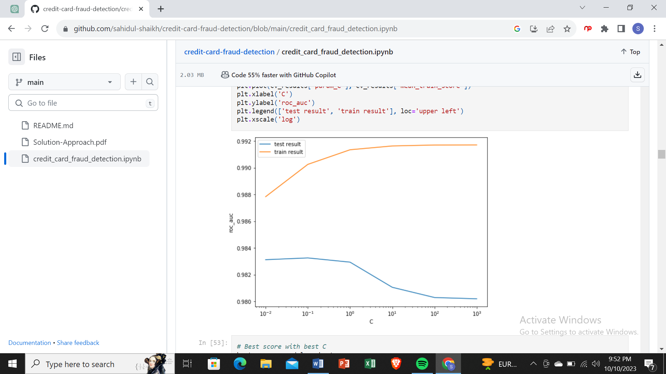

# Best score with best C

best_score = model_cv.best_score_

best_C = model_cv.best_params_['C']

print(" The highest test roc_auc is {0} at C = {1}".format(best_score, best_C))

The highest test roc_auc is 0.9832637280039689 at C = 0.1

Logistic regression with optimal C

# Instantiate the model with best C

logistic_bal_rus = LogisticRegression(C=0.1)

# Fit the model on the train set

logistic_bal_rus_model = logistic_bal_rus.fit(X_train_rus, y_train_rus)

Prediction on the train set

# Predictions on the train set

y_train_pred = logistic_bal_rus_model.predict(X_train_rus)

# Confusion matrix

confusion = metrics.confusion_matrix(y_train_rus, y_train_pred)

print(confusion)

[[391 5]

[ 32 364]]

TP = confusion[1,1] # true positive

TN = confusion[0,0] # true negatives

FP = confusion[0,1] # false positives

FN = confusion[1,0] # false negatives

# Accuracy

print("Accuracy:-",metrics.accuracy_score(y_train_rus, y_train_pred))

# Sensitivity

print("Sensitivity:-",TP / float(TP+FN))

# Specificity

print("Specificity:-", TN / float(TN+FP))

# F1 score

print("F1-Score:-", f1_score(y_train_rus, y_train_pred))

Accuracy:- 0.9532828282828283

Sensitivity:- 0.9191919191919192

Specificity:- 0.9873737373737373

F1-Score:- 0.9516339869281046

# classification_report

print(classification_report(y_train_rus, y_train_pred))

precision recall f1-score support

0 0.92 0.99 0.95 396

1 0.99 0.92 0.95 396

accuracy 0.95 792

macro avg 0.96 0.95 0.95 792

weighted avg 0.96 0.95 0.95 792

# Predicted probability

y_train_pred_proba = logistic_bal_rus_model.predict_proba(X_train_rus)[:,1]

# roc_auc

auc = metrics.roc_auc_score(y_train_rus, y_train_pred_proba)

auc

0.9892230384654627

# Plot the ROC curve

draw_roc(y_train_rus, y_train_pred_proba)

Prediction on the test set

# Prediction on the test set

y_test_pred = logistic_bal_rus_model.predict(X_test)

# Confusion matrix

confusion = metrics.confusion_matrix(y_test, y_test_pred)

print(confusion)

[[55658 1208]

[ 13 83]]

TP = confusion[1,1] # true positive

TN = confusion[0,0] # true negatives

FP = confusion[0,1] # false positives

FN = confusion[1,0] # false negatives

# Accuracy

print("Accuracy:-",metrics.accuracy_score(y_test, y_test_pred))

# Sensitivity

print("Sensitivity:-",TP / float(TP+FN))

# Specificity

print("Specificity:-", TN / float(TN+FP))

Accuracy:- 0.9785646571398476

Sensitivity:- 0.8645833333333334

Specificity:- 0.978757078043119

# classification_report

print(classification_report(y_test, y_test_pred))

precision recall f1-score support

0 1.00 0.98 0.99 56866

1 0.06 0.86 0.12 96

accuracy 0.98 56962

macro avg 0.53 0.92 0.55 56962

weighted avg 1.00 0.98 0.99 56962

threshold = thresholds[np.argmax(tpr-fpr)]

print("Threshold=",threshold)

Train auc = 0.9897539730968845

Threshold= 0.5311563613510013

We can see that the threshold is 0.53, for which the TPR is the highest and FPR is the lowest and we got the best ROC score.

**ANALYSIS**

# importing data

transaction_dataset= pd.read_csv("/content/drive/MyDrive/google_collab/creditcard.csv")

transaction_dataset.head(10)

[**Data analysis**](https://github.com/nano-bot01/Credit-Card-Fraud-Detection-/blob/main/README.md#data-analysis)

* shape
* info()
* describe()
* isnull
* count_values()
* dtypes

**Seperating data for analysis**

* 0 : Normal transaction
* 1 : Fraudulent transaction

legit = transaction_dataset[transaction_dataset.Class == 0]

fraud = transaction_dataset[transaction_dataset.Class == 1]

print("Shape of legit : ", legit.shape)

print("Shape of fraud : ", fraud.shape)

Shape of legit : (284315, 31)

Shape of fraud : (492, 31)

*# measures*

legit.Amount.describe()

count 284315.000000

mean 88.291022

std 250.105092

min 0.000000

25% 5.650000

50% 22.000000

75% 77.050000

max 25691.160000

Name: Amount, dtype: float64

fraud.Amount.describe()

*# fraud transaction description*

count 492.000000

mean 122.211321

std 256.683288

min 0.000000

25% 1.000000

50% 9.250000

75% 105.890000

max 2125.870000

Name: Amount, dtype: float64

*# comparing the values for both transaction*

transaction_dataset.groupby('Class').mean()

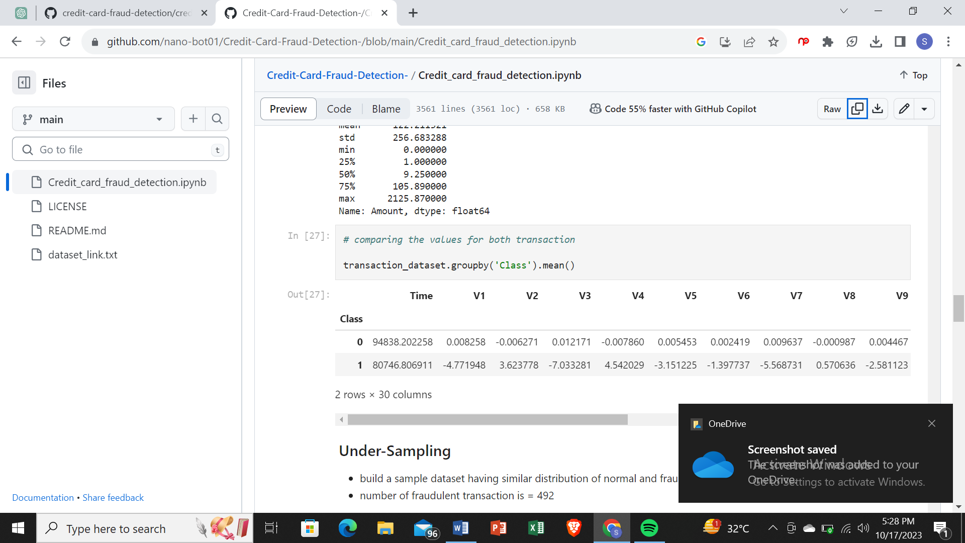

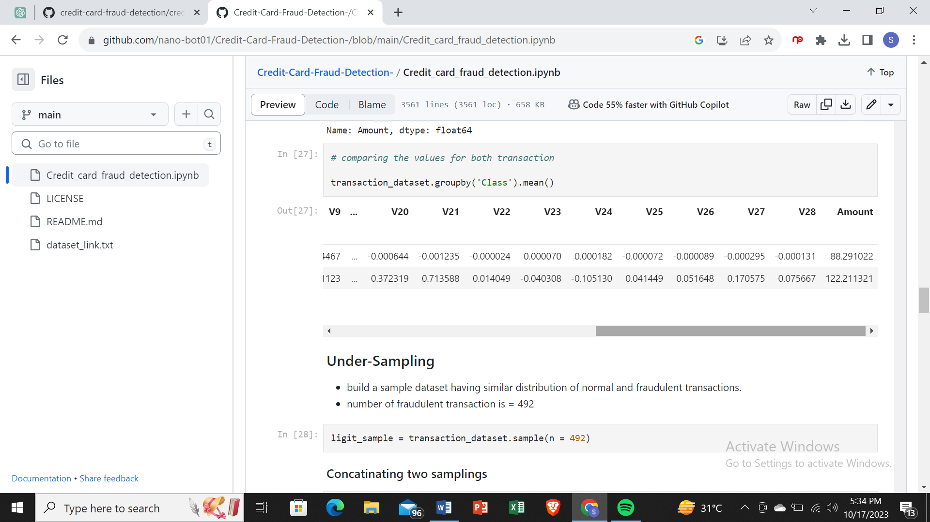

**Under-Sampling**

* build a sample dataset having similar distribution of normal and fraudulent transactions.
* number of fraudulent transaction is = 492

ligit_sample = transaction_dataset.sample(n = 492)

**Concatinating two samplings**

new_transaction_dataset2 = pd.concat([ligit_sample, fraud], axis = 0)

new_transaction_dataset2.head()

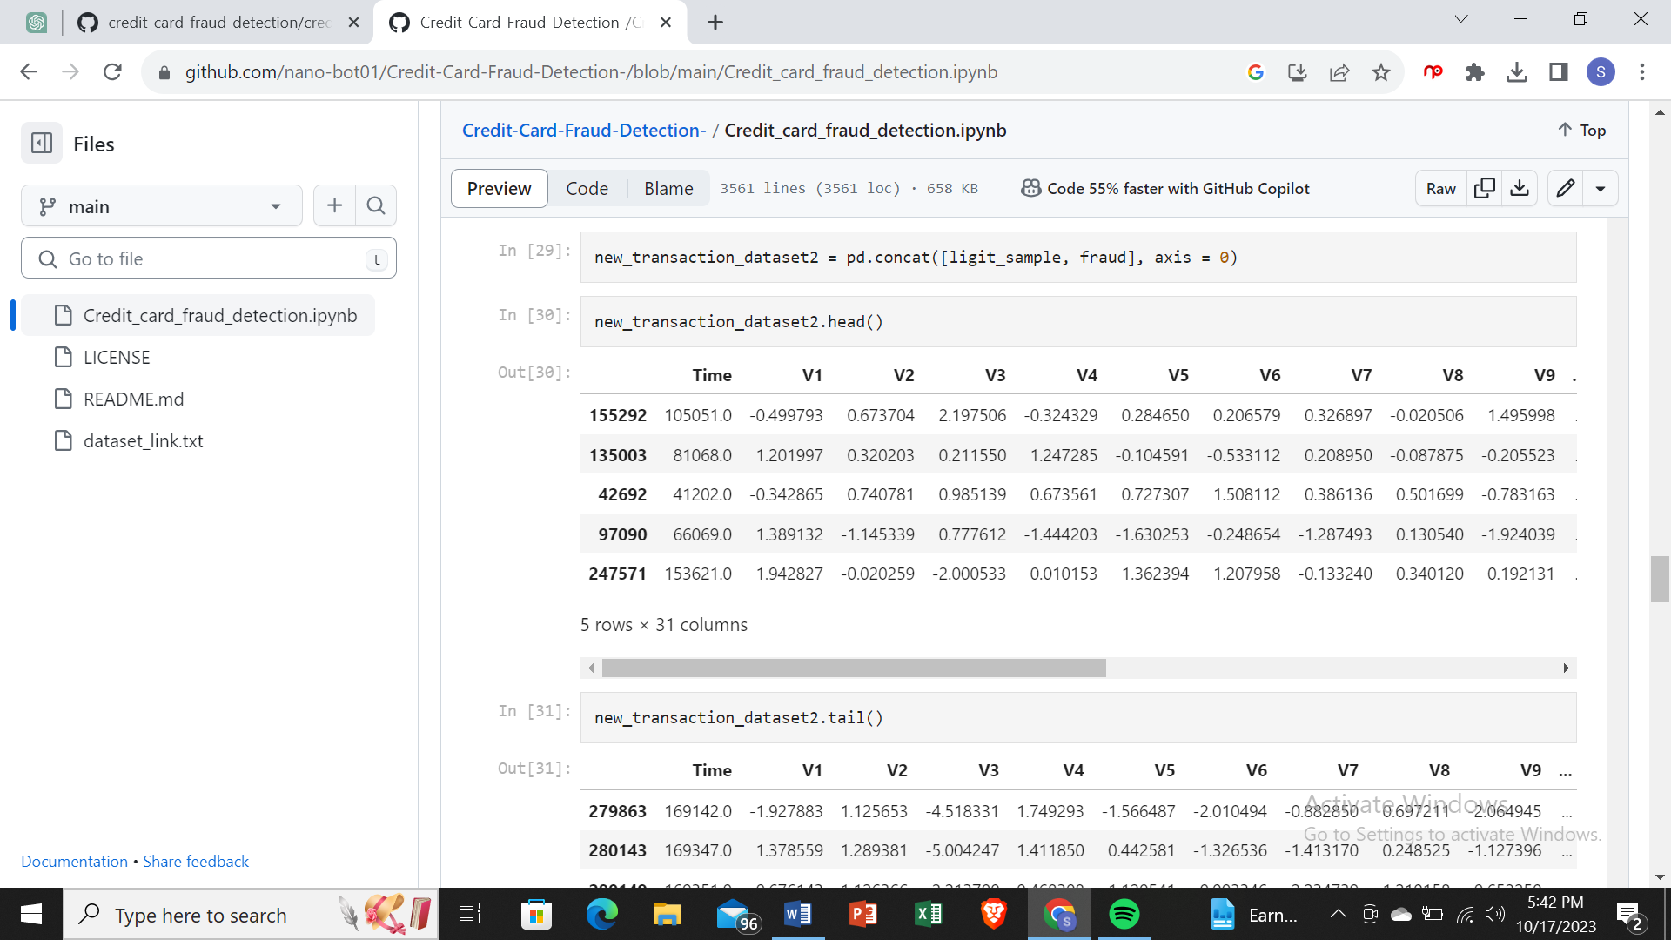

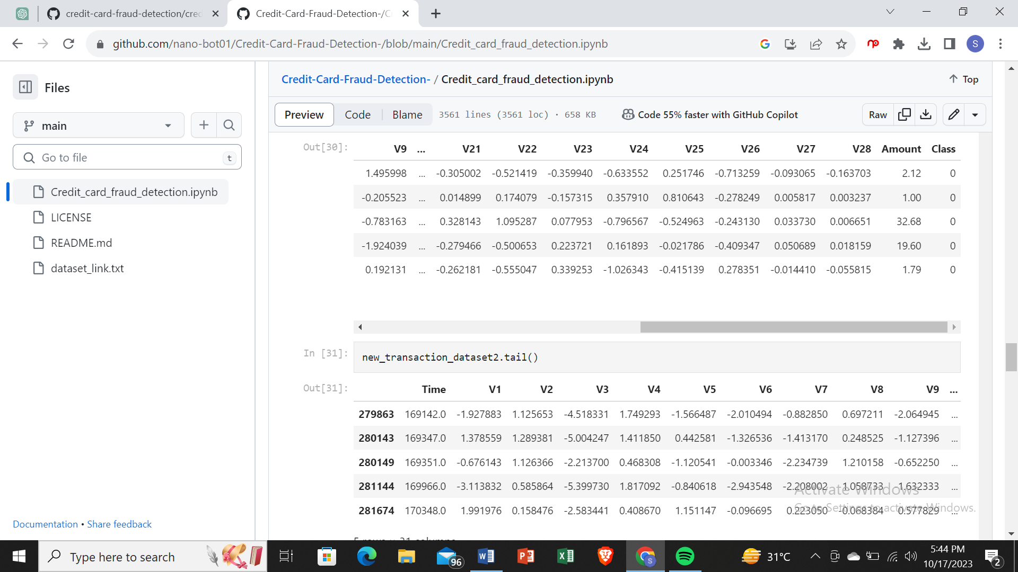

new_transaction_dataset2['Class'].value_counts()

1 494

0 490

Name: Class, dtype: int64

new_transaction_dataset2.groupby('Class').mean()

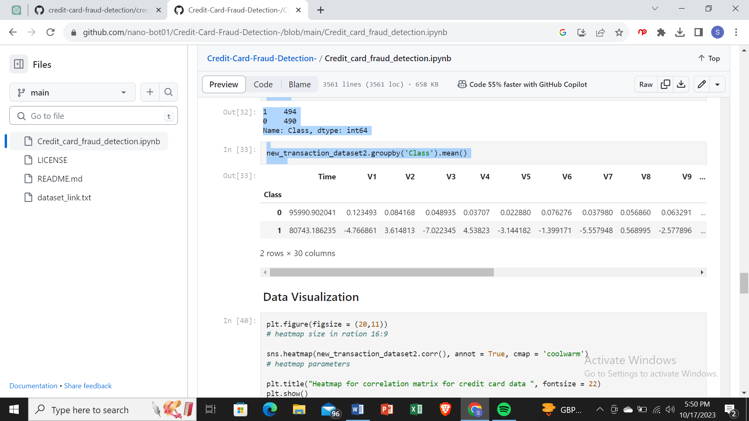

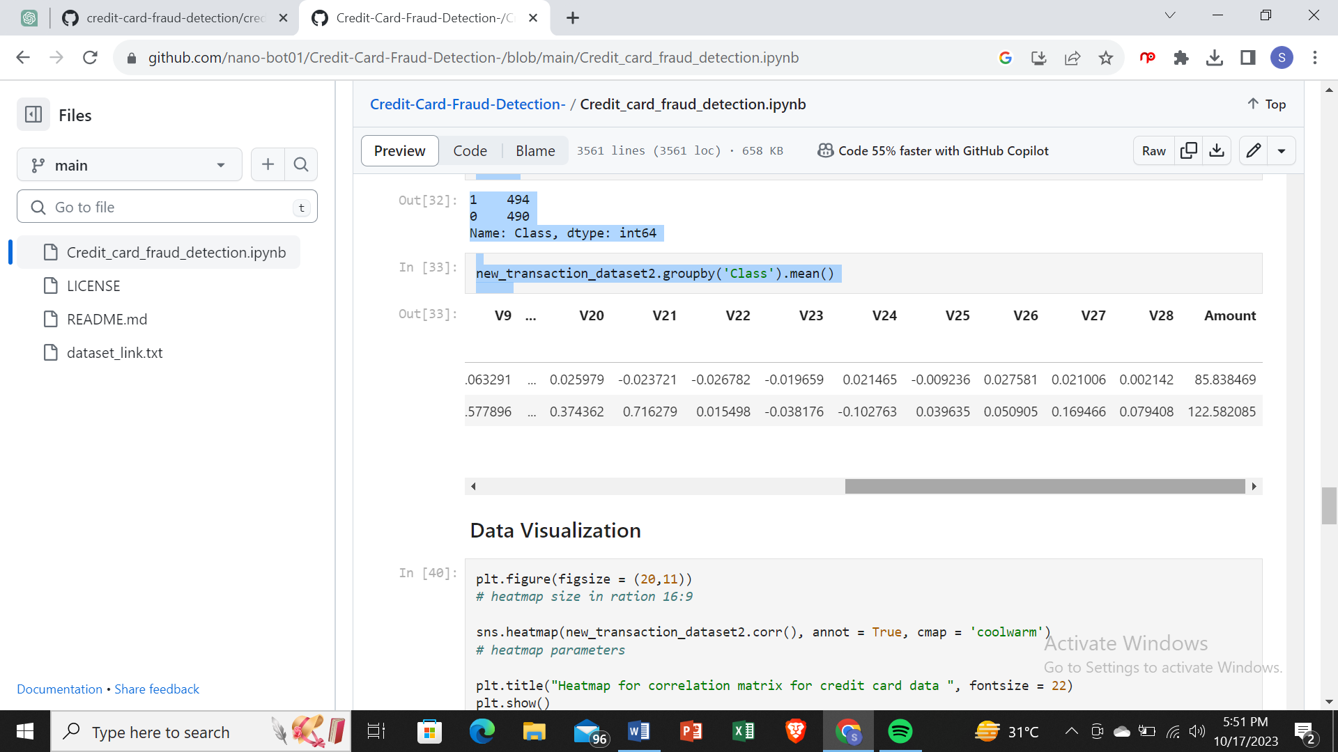

### Data Visualization

plt.figure(figsize = (20,11))

*# heatmap size in ration 16:9*

sns.heatmap(new_transaction_dataset2.corr(), annot = True, cmap = 'coolwarm')

*# heatmap parameters*

plt.title("Heatmap for correlation matrix for credit card data ", fontsize = 22)

plt.show()

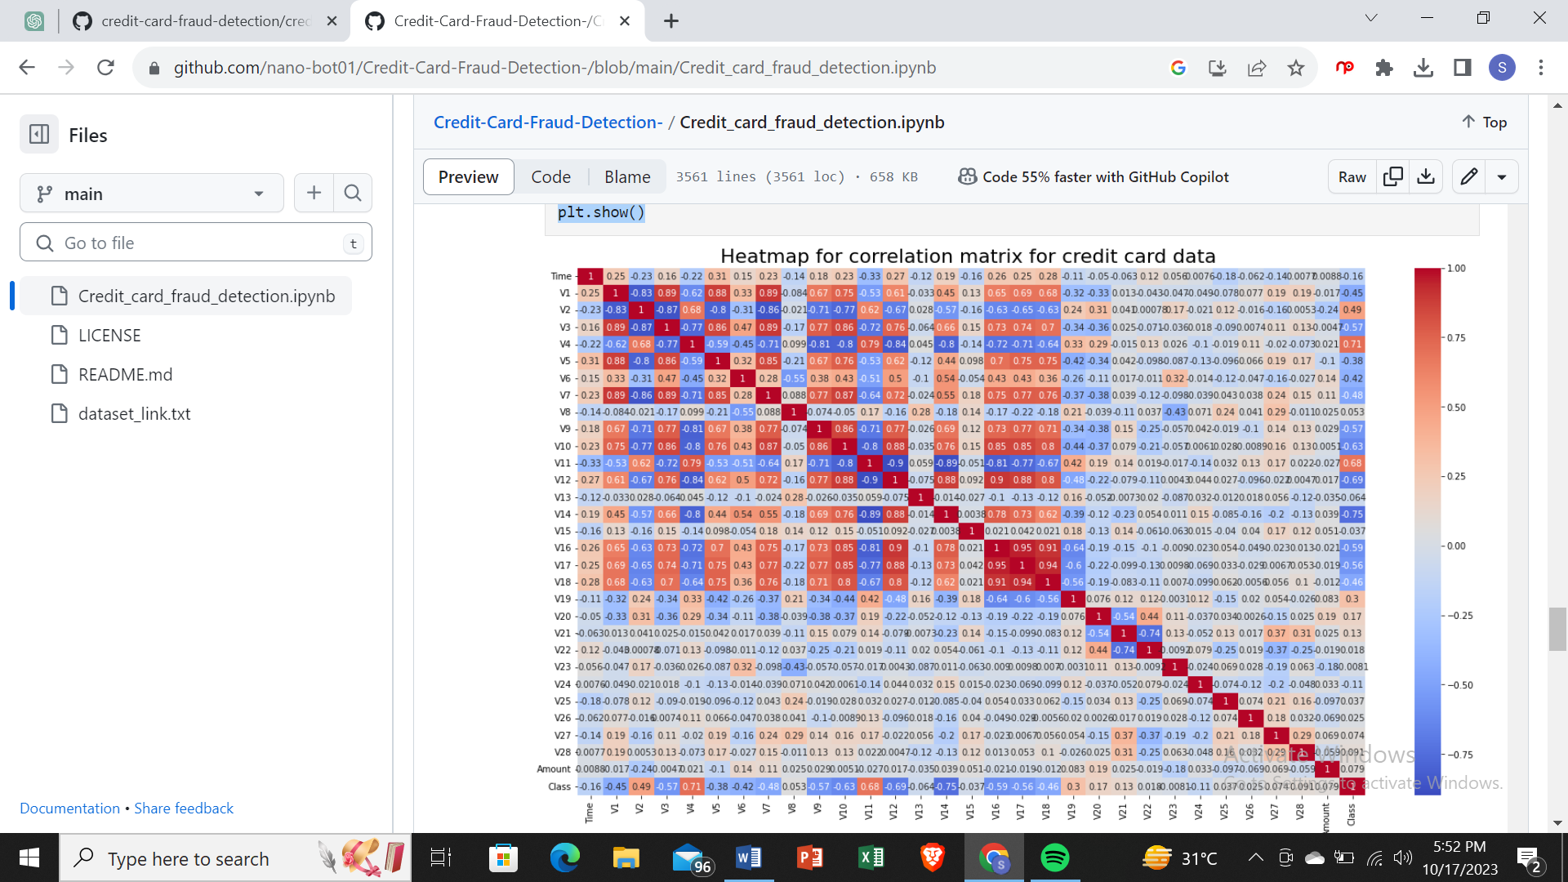

sns.countplot(new_transaction_dataset2.Class)

/usr/local/lib/python3.8/dist-packages/seaborn/_decorators.py:36: FutureWarning: Pass the following variable as a keyword arg: x. From version 0.12, the only valid positional argument will be `data`, and passing other arguments without an explicit keyword will result in an error or misinterpretation.

warnings.warn(

<AxesSubplot:xlabel='Class', ylabel='count'>

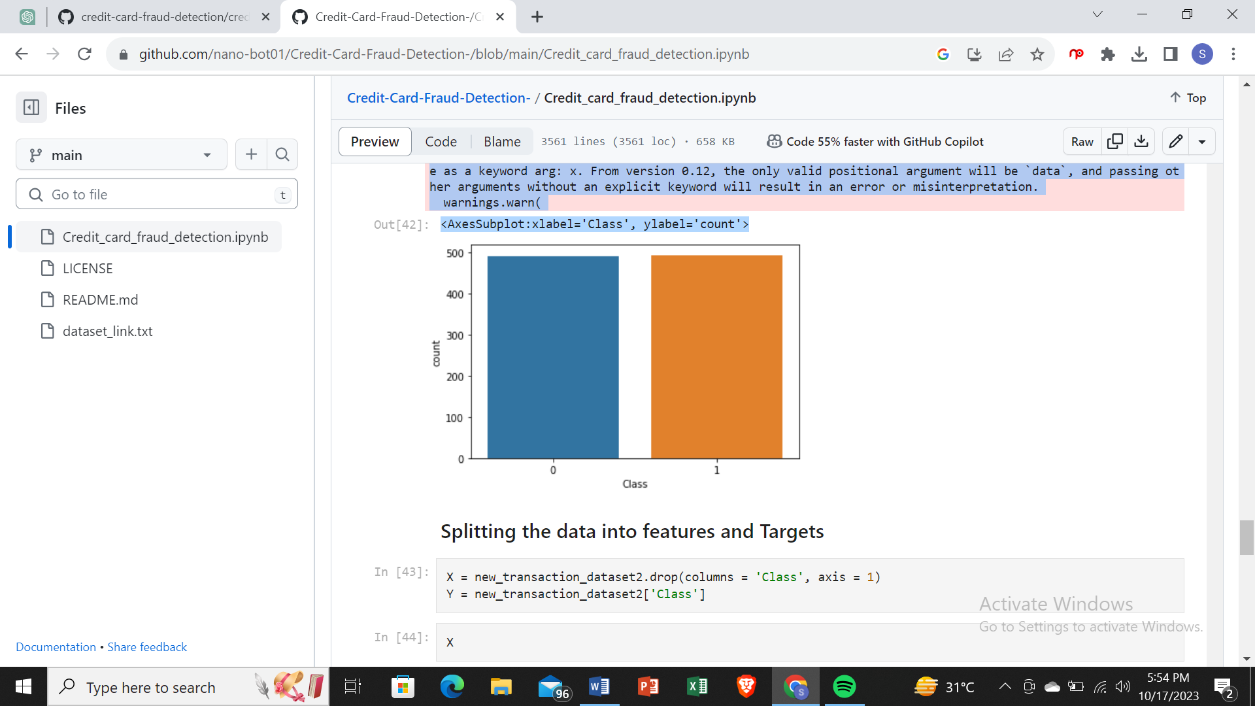

### Splitting the data into features and Targets

X = new_transaction_dataset2.drop(columns = 'Class', axis = 1)

Y = new_transaction_dataset2['Class']

X

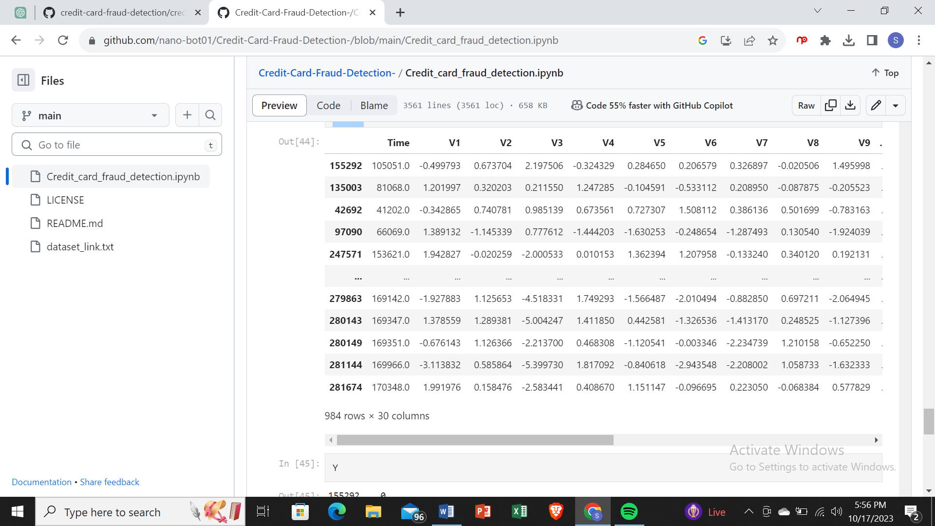

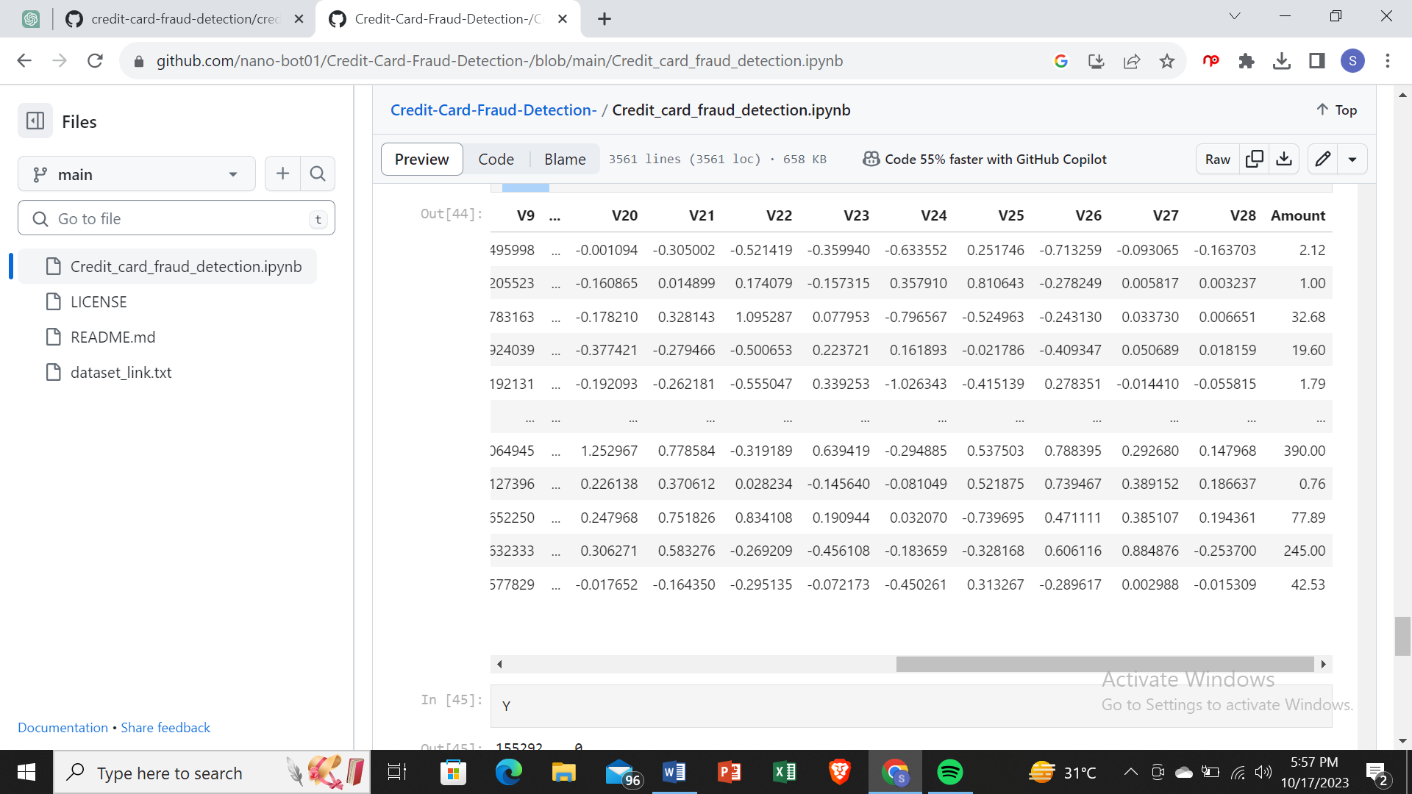

Y

155292 0

135003 0

42692 0

97090 0

247571 0

..

279863 1

280143 1

280149 1

281144 1

281674 1

Name: Class, Length: 984, dtype: int64

### Splitting the data into training and testing data

X_train, X_test, Y_train, Y_test = train_test_split(X,Y, test_size = 0.2, stratify = Y, random_state = 2)

print("Shape of X_train ", X_train.shape)

print("Shape of X_test ", X_test.shape)

print("Shape of Y_train ", Y_train.shape)

print("Shape of Y_test ", Y_test.shape)

Shape of X_train (787, 30)

Shape of X_test (197, 30)

Shape of Y_train (787,)

Shape of Y_test (197,)

### Model Training

model = LogisticRegression()

model.fit(X_train, Y_train)

LogisticRegression()

## Model Evaluation

* Accuracy Score

*# accuracy on training data*

X_train_prediction = model.predict(X_train)

traning_data_accuracy = accuracy_score(X_train_prediction, Y_train)

print("Accuracy on Training data ",traning_data_accuracy)

Accuracy on Training data 0.9390088945362135

*# accuracy on testing data*

X_test_prediction = model.predict(X_test)

test_data_accuracy = accuracy_score(X_test_prediction, Y_test)

print("Accuracy on Training data ",test_data_accuracy)

Accuracy on Training data 0.9441624365482234

Data Preprocessing

**SCALING**

Standardization and Robust Scalar

Since fraud transactions which are also low in number have relatively smaller value(amount) so we need to have our data scaled, We are going to use robust scalar to scale our data.

Go through sklaern.preprocessing to know about all different kind of scalars present

from sklearn.preprocessing import RobustScaler

rob_scaler = RobustScaler()

df['scaled_amount'] = rob_scaler.fit_transform(df['Amount'].values.reshape(-1,1))

df.drop(['Time','Amount'],axis=1,inplace=True)

df.drop(['Time_min','Time_hour'],axis=1,inplace=True)

#inserting these scaled columns at 0,1

scaled_amount = df['scaled_amount']

df.drop(['scaled_amount'],axis=1,inplace=True)

df.insert(0,'scaled_amount',scaled_amount)

df.head()

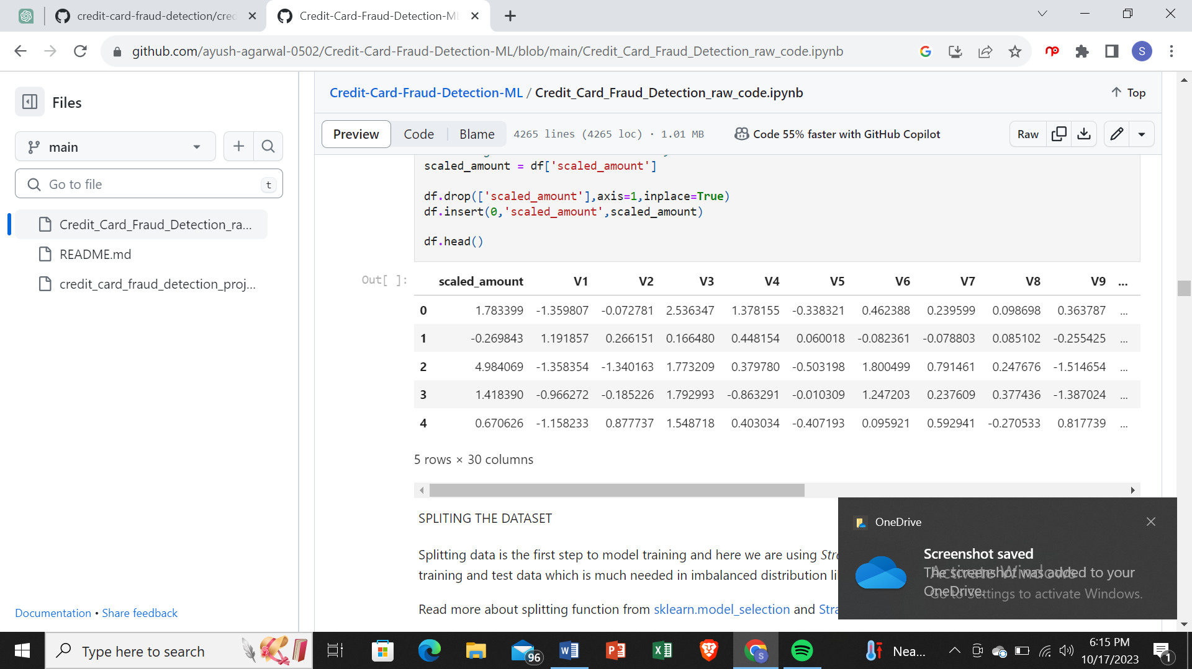

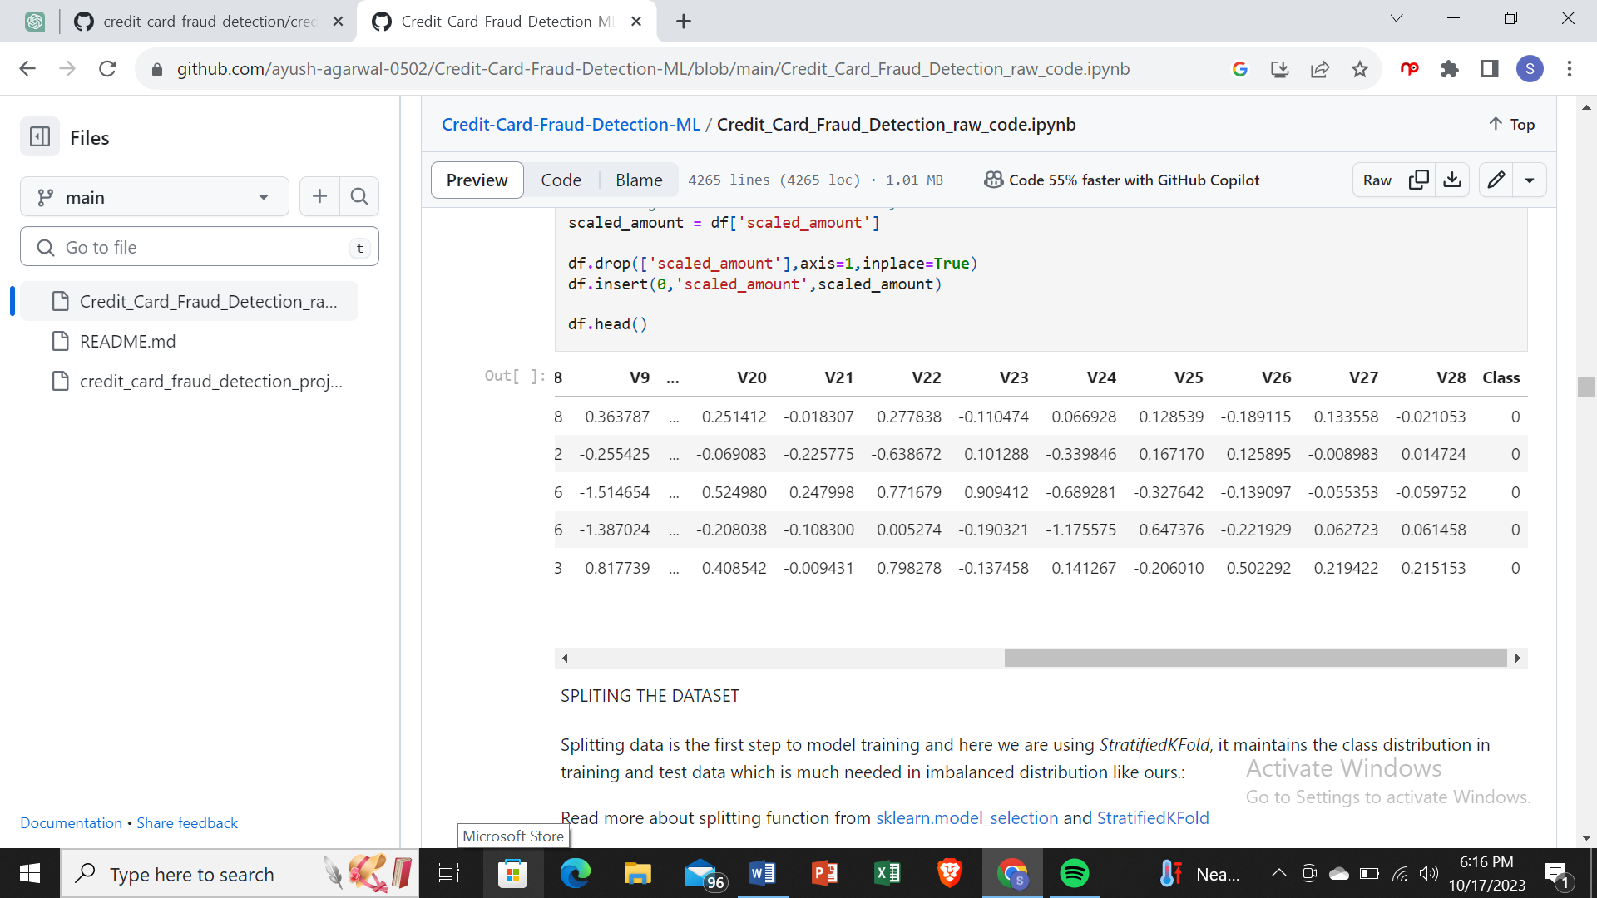

Splitting The Dataset

Splitting data is the first step to model training and here we are using *StratifiedKFold*, it maintains the class distribution in training and test data which is much needed in imbalanced distribution like ours.:

Read more about splitting function from [sklearn.model_selection](https://scikit-learn.org/stable/modules/classes.html#module-sklearn.model_selection) and [StratifiedKFold](https://scikit-learn.org/stable/modules/generated/sklearn.model_selection.StratifiedKFold.html#sklearn.model_selection.StratifiedKFold)

fr**om** sklearn.model_selection **import** StratifiedKFold

X **=** df**.**drop('Class',axis**=**1)

y **=** df['Class']

sss **=** StratifiedKFold(n_splits**=**5,random_state**=None**,shuffle**=False**)

**for** train_index, test_index **in** sss**.**split(X,y):

print("Train:", train_index, "Test:", test_index)

original_Xtrain, original_Xtest **=** X**.**iloc[train_index], X**.**iloc[test_index]

original_ytrain, original_ytest **=** y**.**iloc[train_index],y**.**iloc[test_index]

*#converting it into an array*

original_Xtrain **=** original_Xtrain**.**values

original_Xtest **=** original_Xtest**.**values

original_ytrain **=** original_ytrain**.**values

original_ytest **=** original_ytest**.**values

*#check if both train and test distributions are similarly distributed*

train_unique_label, train_counts_label **=** np**.**unique(original_ytrain, return_counts**=True**)

test_unique_label, test_counts_label **=** np**.**unique(original_ytest,return_counts**=True**)

print("Label dstributions: \n")

print(train_counts_label**/**len(original_ytrain))

print(test_counts_label**/**len(original_ytest))

Train: [ 30442 30473 30496 ... 284796 284797 284798] Test: [ 0 1 2 ... 57016 57017 57018]

Train: [ 0 1 2 ... 284796 284797 284798] Test: [ 30442 30473 30496 ... 113962 113963 113964]

Train: [ 0 1 2 ... 284796 284797 284798] Test: [ 80757 81183 81606 ... 170942 170943 170944]

Train: [ 0 1 2 ... 284796 284797 284798] Test: [150644 150651 150657 ... 227860 227861 227862]

Train: [ 0 1 2 ... 227860 227861 227862] Test: [212511 212639 213087 ... 284796 284797 284798]

Label dstributions:

[0.99827072 0.00172928]

[0.99827946 0.00172054]

**UNDERSAMPLING TO MAKE THE DATASET BALANCED**

since our classes are highly skewed, we have to make them equivalent in occurence to have a normal distribution of the classes, shuffle the data before creating the sub-samples.

df **=** df**.**sample(frac**=**1)

fraud_df **=** df**.**loc[df['Class']**==**1]

non_fraud_df **=** df**.**loc[df['Class']**==**0][:492]

normal_distributed_df **=** pd**.**concat([fraud_df, non_fraud_df])

new_df **=** normal_distributed_df**.**sample(frac**=**1,random_state**=**42)

new_df**.**head()

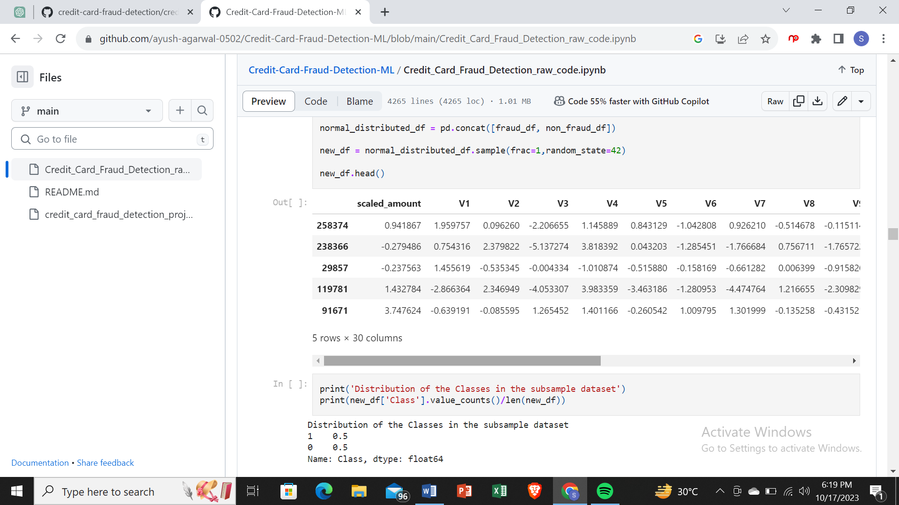

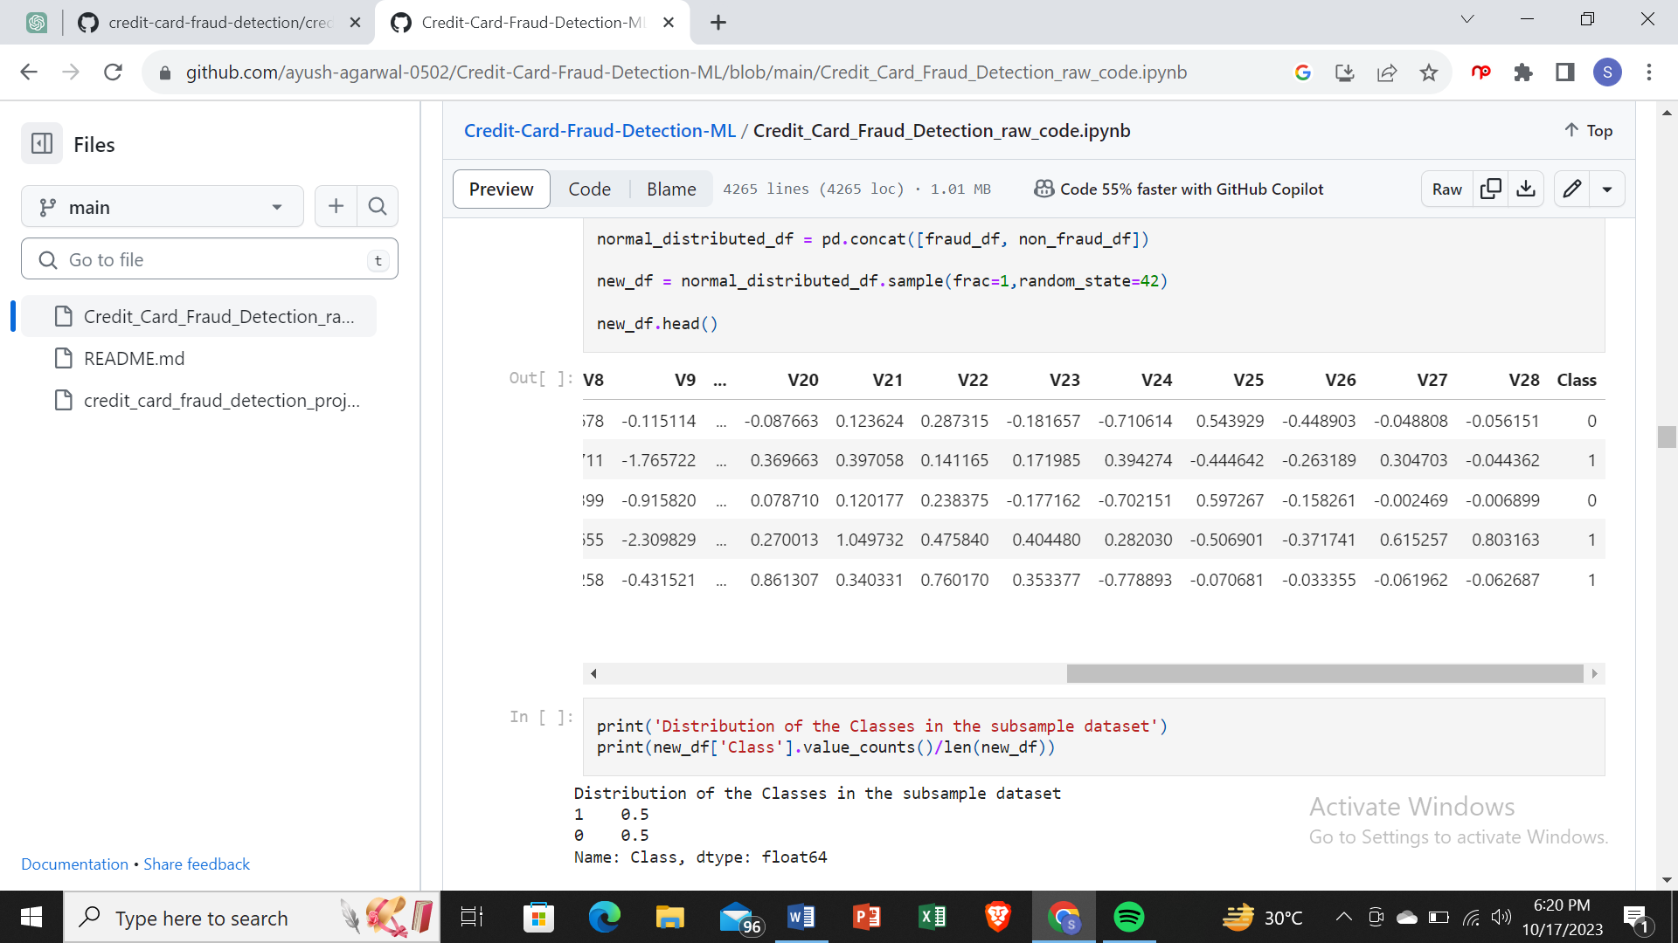

print('Distribution of the Classes in the subsample dataset')

print(new_df['Class']**.**value_counts()**/**len(new_df))

Distribution of the Classes in the subsample dataset

1 0.5

0 0.5

Name: Class, dtype: float64

**REMOVING OUTLIERS**

We will use interquatile range to remove outliers from highly correlated features

IQR is used to measure variability by dividing a data set into quartiles. The data is sorted in ascending order and split into 4 equal parts. Q1, Q2, Q3 called first, second and third quartiles are the values which separate the 4 equal parts.

* Q1 represents the 25th percentile of the data.
* Q2 represents the 50th percentile of the data.
* Q3 represents the 75th percentile of the data.

IQR is the range between the first and the third quartiles namely Q1 and Q3: IQR = Q3 – Q1. The data points which fall below Q1 – 1.5 IQR or above Q3 + 1.5 IQR are outliers.

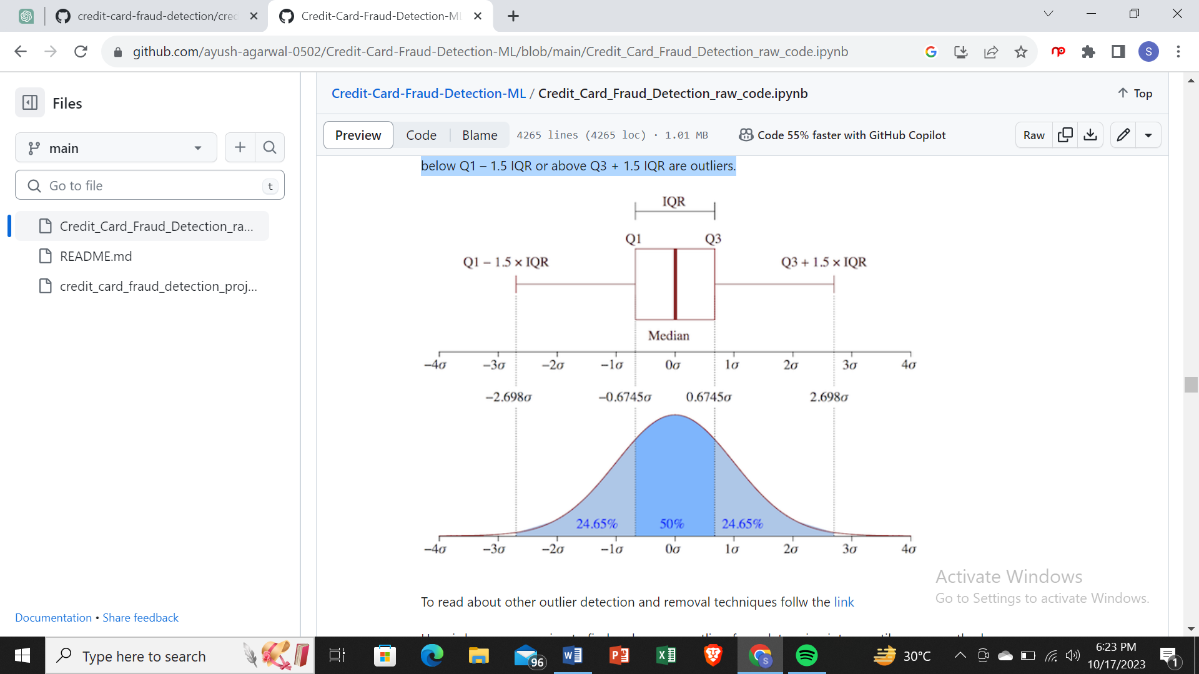

To read about other outlier detection and removal techniques follw the [link](https://https/towardsdatascience.com/5-ways-to-detect-outliers-that-every-data-scientist-should-know-python-code-70a54335a623)

Here is how we are going to find and remove outliers from data using interquartile range method

Go through the example to complete the cell below and run for yourself

v14_fraud = new_df['V14'].loc[new_df['Class'] == 1].values

q25, q75 = np.percentile(v14_fraud, 25), np.percentile(v14_fraud, 75)

v14_iqr = q75 - q25

v14_cut_off = v14_iqr * 1.5

v14_lower, v14_upper = q25 - v14_cut_off, q75 + v14_cut_off

outliers = [x for x in v14_fraud if x < v14_lower or x > v14_upper]

new_df = new_df.drop(new_df[(new_df['V14'] > v14_upper) | (new_df['V14'] < v14_lower)].index)

*#Complete Line 2-16*

v14_fraud **=** new_df['V14']**.**loc[new_df['Class'] **==** 1]**.**values

q25, q75 **=**np**.**percentile(v14_fraud, 25), np**.**percentile(v14_fraud, 75)

print('Quartile 25: {} | Quartile 75: {}'**.**format(q25, q75))

v14_iqr **=**q75 **-** q25

print('iqr: {}'**.**format(v14_iqr))

v14_cut_off **=**v14_iqr **\*** 1.5

v14_lower, v14_upper **=** q25 **-** v14_cut_off, q75 **+** v14_cut_off

print('Cut Off: {}'**.**format(v14_cut_off))

print('V14 Lower: {}'**.**format(v14_lower))

print('V14 Upper: {}'**.**format(v14_upper))

outliers **=** [x **for** x **in** v14_fraud **if** x **<** v14_lower **or** x **>** v14_upper]

print('Feature V14 Outliers for Fraud Cases: {}'**.**format(len(outliers)))

print('V14 outliers:{}'**.**format(outliers))

new_df **=** new_df**.**drop(new_df[(new_df['V14'] **>** v14_upper) **|** (new_df['V14'] **<** v14_lower)]**.**index)

print('----' **\*** 44)

*###################################################################################################################*

v12_fraud **=** new_df['V12']**.**loc[new_df['Class'] **==** 1]**.**values

q25, q75 **=** np**.**percentile(v12_fraud, 25), np**.**percentile(v12_fraud, 75)

v12_iqr **=** q75 **-** q25

v12_cut_off **=** v12_iqr **\*** 1.5

v12_lower, v12_upper **=** q25 **-** v12_cut_off, q75 **+** v12_cut_off

print('V12 Lower: {}'**.**format(v12_lower))

print('V12 Upper: {}'**.**format(v12_upper))

outliers **=** [x **for** x **in** v12_fraud **if** x **<** v12_lower **or** x **>** v12_upper]

print('V12 outliers: {}'**.**format(outliers))

print('Feature V12 Outliers for Fraud Cases: {}'**.**format(len(outliers)))

new_df **=** new_df**.**drop(new_df[(new_df['V12'] **>** v12_upper) **|** (new_df['V12'] **<** v12_lower)]**.**index)

print('Number of Instances after outliers removal: {}'**.**format(len(new_df)))

print('----' **\*** 44)

*##################################################################################################################*

v10_fraud **=** new_df['V10']**.**loc[new_df['Class'] **==** 1]**.**values

q25, q75 **=** np**.**percentile(v10_fraud, 25), np**.**percentile(v10_fraud, 75)

v10_iqr **=** q75 **-** q25

v10_cut_off **=** v10_iqr **\*** 1.5

v10_lower, v10_upper **=** q25 **-** v10_cut_off, q75 **+** v10_cut_off

print('V10 Lower: {}'**.**format(v10_lower))

print('V10 Upper: {}'**.**format(v10_upper))

outliers **=** [x **for** x **in** v10_fraud **if** x **<** v10_lower **or** x **>** v10_upper]

print('V10 outliers: {}'**.**format(outliers))

print('Feature V10 Outliers for Fraud Cases: {}'**.**format(len(outliers)))

new_df **=** new_df**.**drop(new_df[(new_df['V10'] **>** v10_upper) **|** (new_df['V10'] **<** v10_lower)]**.**index)

print('Number of Instances after outliers removal: {}'**.**format(len(new_df)))

Quartile 25: -9.692722964972385 | Quartile 75: -4.282820849486865

iqr: 5.40990211548552

Cut Off: 8.11485317322828

V14 Lower: -17.807576138200666

V14 Upper: 3.832032323741415

Feature V14 Outliers for Fraud Cases: 4

V14 outliers:[-18.049997689859396, -18.4937733551053, -18.8220867423816, -19.2143254902614]

--------------------------------------------------------------------------------------------------------------------------------------------------------------------------------

V12 Lower: -17.3430371579634

V12 Upper: 5.776973384895937

V12 outliers: [-18.683714633344298, -18.4311310279993, -18.553697009645802, -18.047596570821604]

Feature V12 Outliers for Fraud Cases: 4

Number of Instances after outliers removal: 976

--------------------------------------------------------------------------------------------------------------------------------------------------------------------------------

V10 Lower: -14.89885463232024

V10 Upper: 4.920334958342141

V10 outliers: [-22.1870885620007, -15.563791338730098, -23.2282548357516, -14.9246547735487, -15.2318333653018, -16.2556117491401, -16.7460441053944, -24.5882624372475, -18.9132433348732, -16.6011969664137, -14.9246547735487, -18.2711681738888, -17.141513641289198, -22.1870885620007, -24.403184969972802, -15.563791338730098, -15.2399619587112, -15.124162814494698, -15.2399619587112, -15.1237521803455, -19.836148851696, -15.346098846877501, -16.3035376590131, -22.1870885620007, -20.949191554361104, -16.6496281595399, -22.1870885620007]

Feature V10 Outliers for Fraud Cases: 27

Number of Instances after outliers removal: 945

f, (ax1,ax2,ax3) **=** plt**.**subplots(1,3, figsize**=**(20,6))

colors **=** ['red','green']

*#feature V14*

sns**.**boxplot(x**=**'Class',y**=**'V14',data**=**new_df,ax**=**ax1,palette**=**colors)

ax1**.**set_title("V14 Feature \n Reduction of outliers", fontsize**=**14)

ax1**.**annotate('Fewer extreme \n outliers', xy**=**(0.98, **-**17.5), xytext**=**(0, **-**12),arrowprops**=**dict(facecolor**=**'black'),fontsize**=**14)

*#feature v12*

sns**.**boxplot(x**=**'Class',y**=**'V12',data**=**new_df,ax**=**ax2,palette**=**colors)

ax2**.**set_title("V12 Feature \n Reduction of outliers", fontsize**=**14)

ax2**.**annotate('Fewer extreme \n outliers', xy**=**(0.98, **-**17.3), xytext**=**(0, **-**12),arrowprops**=**dict(facecolor**=**'black'),fontsize**=**14)

*#feature V10*

sns**.**boxplot(x**=**'Class',y**=**'V10',data**=**new_df,ax**=**ax3,palette**=**colors)

ax3**.**set_title("V10 Feature \n Reduction of outliers", fontsize**=**14)

ax3**.**annotate('Fewer extreme \n outliers', xy**=**(0.95, **-**16.5), xytext**=**(0, **-**12),arrowprops**=**dict(facecolor**=**'black'),fontsize**=**14)

Text(0, -12, 'Fewer extreme \n outliers')

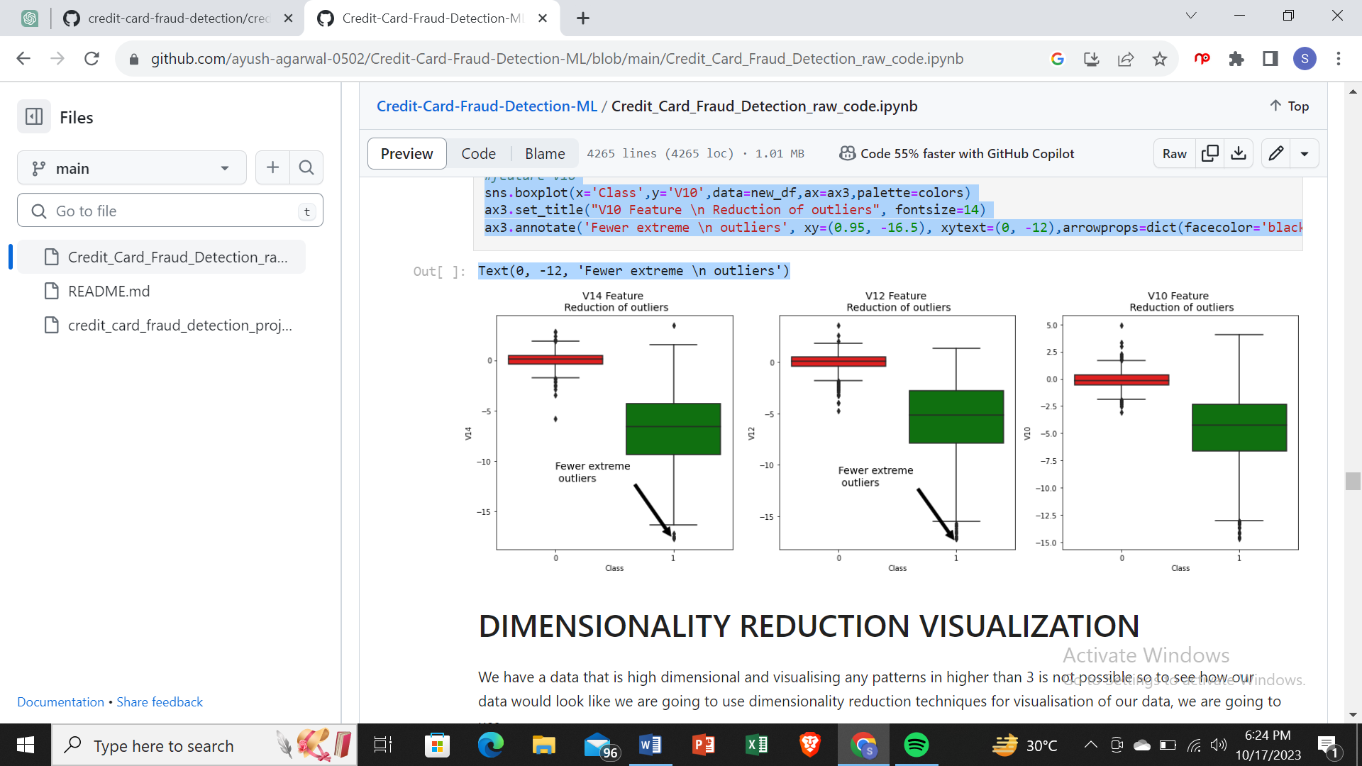

SMOTE (Synthetic Minority Oversampling Technique)

We are creating synthetic samples by doing upsampling using SMOTE(Synthetic Minority Oversampling Technique).

# Importing SMOTE

from imblearn.over_sampling import SMOTE

# Instantiate SMOTE

sm = SMOTE(random_state=27)

# Fitting SMOTE to the train set

X_train_smote, y_train_smote = sm.fit_sample(X_train, y_train)

print('Before SMOTE oversampling X_train shape=',X_train.shape)

print('After SMOTE oversampling X_train shape=',X_train_smote.shape)

Before SMOTE oversampling X_train shape= (227845, 29)

After SMOTE oversampling X_train shape= (454898, 29)

Logistic Regression

# Creating KFold object with 5 splits

folds = KFold(n_splits=5, shuffle=True, random_state=4)

# Specify params

params = {"C": [0.01, 0.1, 1, 10, 100, 1000]}

# Specifing score as roc-auc

model_cv = GridSearchCV(estimator = LogisticRegression(),

param_grid = params,

scoring= 'roc_auc',

cv = folds,

verbose = 1,

return_train_score=True)

# Fit the model

model_cv.fit(X_train_smote, y_train_smote)

Fitting 5 folds for each of 6 candidates, totalling 30 fits

[Parallel(n_jobs=1)]: Using backend SequentialBackend with 1 concurrent workers.

[Parallel(n_jobs=1)]: Done 30 out of 30 | elapsed: 1.5min finished

GridSearchCV(cv=KFold(n_splits=5, random_state=4, shuffle=True),

error_score=nan,

estimator=LogisticRegression(C=1.0, class_weight=None, dual=False,

fit_intercept=True,

intercept_scaling=1, l1_ratio=None,

max_iter=100, multi_class='auto',

n_jobs=None, penalty='l2',

random_state=None, solver='lbfgs',

tol=0.0001, verbose=0,

warm_start=False),

iid='deprecated', n_jobs=None,

param_grid={'C': [0.01, 0.1, 1, 10, 100, 1000]},

pre_dispatch='2*n_jobs', refit=True, return_train_score=True,

scoring='roc_auc', verbose=1)

# results of grid search CV

cv_results = pd.DataFrame(model_cv.cv_results_)

cv_results

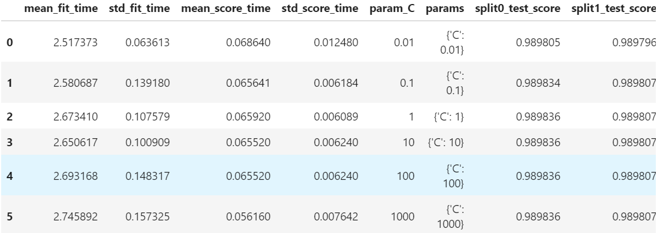

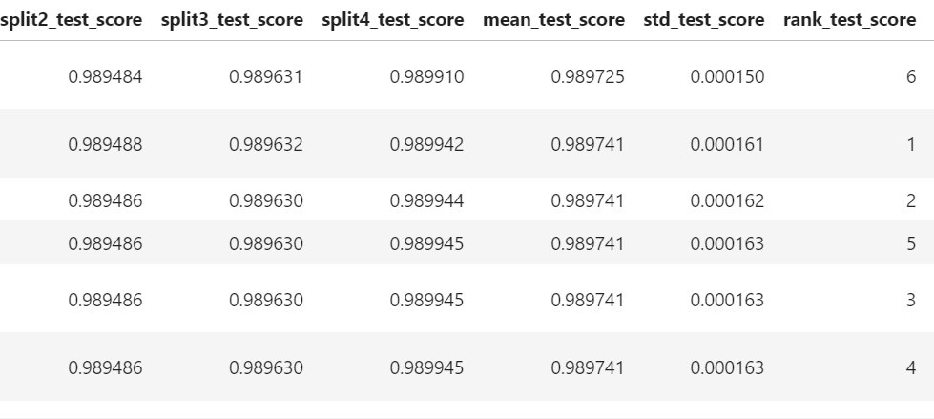

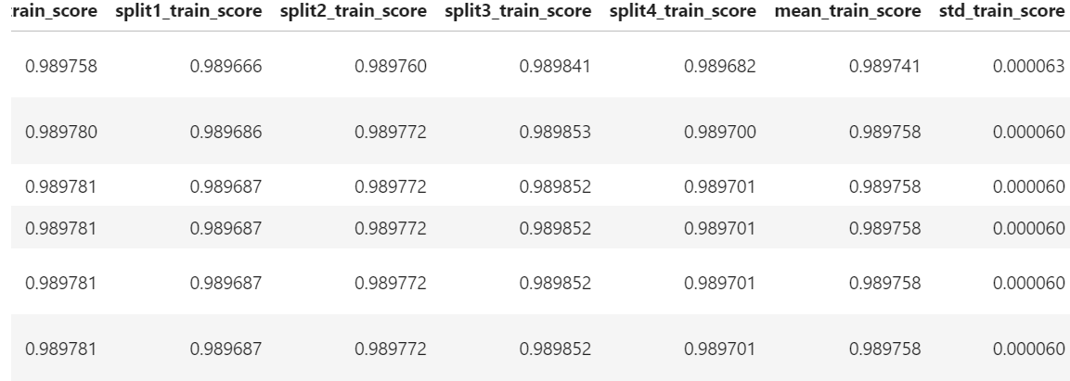

# plot of C versus train and validation scores

plt.figure(figsize=(8, 6))

plt.plot(cv_results['param_C'], cv_results['mean_test_score'])

plt.plot(cv_results['param_C'], cv_results['mean_train_score'])

plt.xlabel('C')

plt.ylabel('roc_auc')

plt.legend(['test result', 'train result'], loc='upper left')

plt.xscale('log')

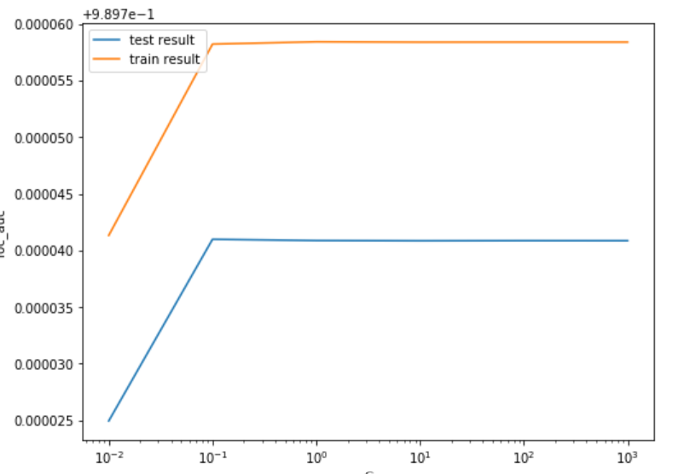

# Best score with best C

best_score = model_cv.best_score_

best_C = model_cv.best_params_['C']

print(" The highest test roc_auc is {0} at C = {1}".format(best_score, best_C))

The highest test roc_auc is 0.9897409900830768 at C = 0.1

Logistic regression with optimal C

# Instantiate the model with best C

logistic_bal_smote = LogisticRegression(C=0.1)

# Fit the model on the train set

logistic_bal_smote_model = logistic_bal_smote.fit(X_train_smote, y_train_smote)

Prediction on the train set

# Predictions on the train set

y_train_pred = logistic_bal_smote_model.predict(X_train_smote)

# Confusion matrix

confusion = metrics.confusion_matrix(y_train_smote, y_train_pred)

print(confusion)

[[221911 5538]

[ 17693 209756]]

TP = confusion[1,1] # true positive

TN = confusion[0,0] # true negatives

FP = confusion[0,1] # false positives

FN = confusion[1,0] # false negatives

# Accuracy

print("Accuracy:-",metrics.accuracy_score(y_train_smote, y_train_pred))

# Sensitivity

print("Sensitivity:-",TP / float(TP+FN))

# Specificity

print("Specificity:-", TN / float(TN+FP))

Accuracy:- 0.9489314087993352

Sensitivity:- 0.9222111330452102

Specificity:- 0.9756516845534603

# classification_report

print(classification_report(y_train_smote, y_train_pred))

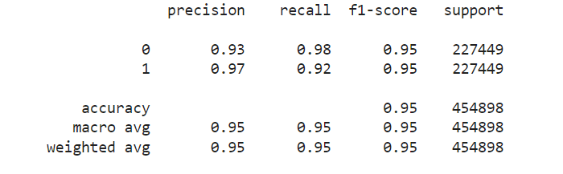

# Predicted probability

y_train_pred_proba_log_bal_smote = logistic_bal_smote_model.predict_proba(X_train_smote)[:,1]

# Plot the ROC curve

draw_roc(y_train_smote, y_train_pred_proba_log_bal_smote)

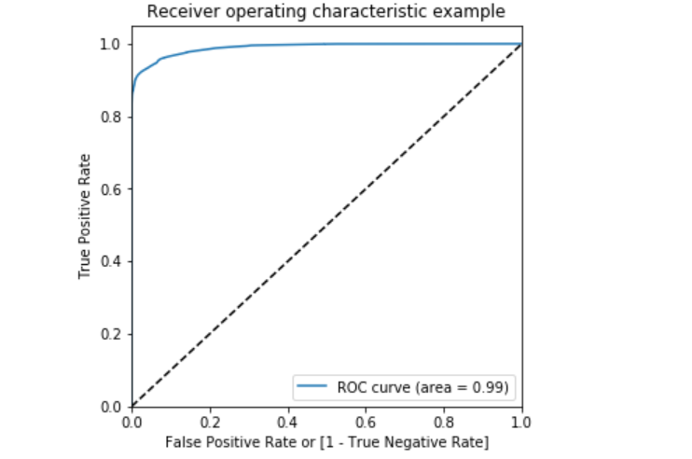

**Prediction on the test set**

*# Prediction on the test set*

y_test_pred **=** logistic_bal_smote_model**.**predict(X_test)

*# Confusion matrix*

confusion **=** metrics**.**confusion_matrix(y_test, y_test_pred)

print(confusion)

[[55416 1450]

[ 10 86]]

TP **=** confusion[1,1] *# true positive*

FP **=** confusion[0,1] *# false positives*

FN **=** confusion[1,0] *# false negatives*

*# Accuracy*

print("Accuracy:-",metrics**.**accuracy_score(y_test, y_test_pred))

*# Sensitivity*

print("Sensitivity:-",TP **/** float(TP**+**FN))

*# Specificity*

print("Specificity:-", TN **/** float(TN**+**FP))

Accuracy:- 0.9743688774972789

Sensitivity:- 0.8958333333333334

Specificity:- 0.9745014595716245

*# classification_report*

print(classification_report(y_test, y_test_pred))

precision recall f1-score support

0 1.00 0.97 0.99 56866

1 0.06 0.90 0.11 96

accuracy 0.97 56962

macro avg 0.53 0.94 0.55 56962

weighted avg 1.00 0.97 0.99 56962

**ROC on the test set**

*# Predicted probabilitY*y_test_pred_proba **=** logistic_bal_smote_model**.**predict_proba(X_test)[:,1]

*# Plot the ROC curve*

draw_roc(y_test, y_test_pred_proba)

*# specify model*

xgb_model **=** XGBClassifier(max_depth**=**2, n_estimators**=**200)

*# set up GridSearchCV()*

model_cv **=** GridSearchCV(estimator **=** xgb_model,

param_grid **=** param_grid,

scoring**=** 'roc_auc',

cv **=** folds,

verbose **=** 1,

return_train_score**=True**)

*# fit the model*

model_cv**.**fit(X_train_smote, y_train_smote)

Fitting 3 folds for each of 6 candidates, totalling 18 fits

[Parallel(n_jobs=1)]: Using backend SequentialBackend with 1 concurrent workers.

[Parallel(n_jobs=1)]: Done 18 out of 18 | elapsed: 45.8min finished

GridSearchCV(cv=3, error_score=nan,

estimator=XGBClassifier(base_score=None, booster=None,

colsample_bylevel=None,

colsample_bynode=None,

colsample_bytree=None, gamma=None,

gpu_id=None, importance_type='gain',

interaction_constraints=None,

learning_rate=None, max_delta_step=None,

max_depth=2, min_child_weight=None,

missing=nan, monotone_constraints=None,

n_estimato...

objective='binary:logistic',

random_state=None, reg_alpha=None,

reg_lambda=None, scale_pos_weight=None,

subsample=None, tree_method=None,

validate_parameters=False,

verbosity=None),

iid='deprecated', n_jobs=None,

param_grid={'learning_rate': [0.2, 0.6],

'subsample': [0.3, 0.6, 0.9]},

pre_dispatch='2*n_jobs', refit=True, return_train_score=True,

scoring='roc_auc', verbose=1)

*# cv results*

cv_results **=** pd**.**DataFrame(model_cv**.**cv_results_)

cv_results

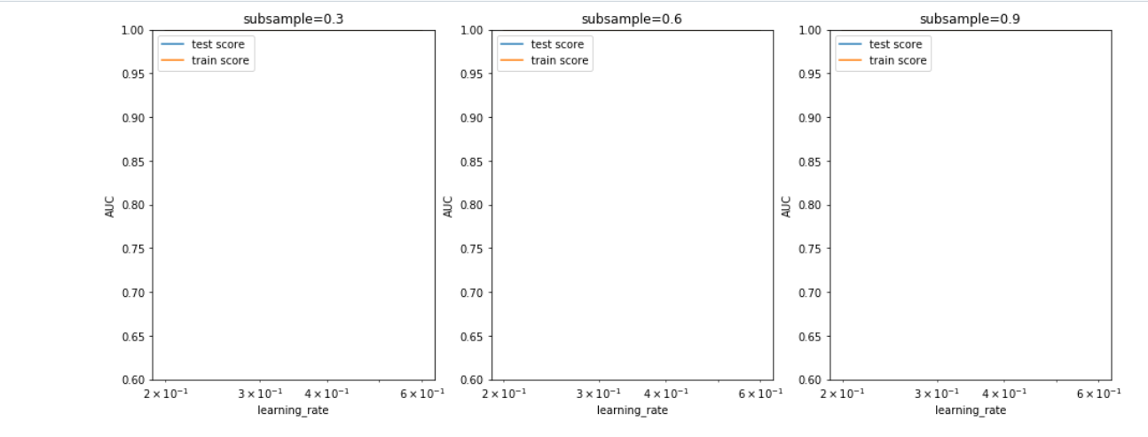

Model with optimal hyperparameters

We see that the train score almost touches to 1. Among the hyperparameters, we can choose the best parameters as learning_rate : 0.2 and subsample: 0.3

model_cv.best_params_

{'learning_rate': 0.6, 'subsample': 0.9}

# chosen hyperparameters

# 'objective':'binary:logistic' outputs probability rather than label, which we need for calculating auc

params = {'learning_rate': 0.6,

'max_depth': 2,

'n_estimators':200,

'subsample':0.9,

'objective':'binary:logistic'}

# fit model on training data

xgb_bal_smote_model = XGBClassifier(params = params)

xgb_bal_smote_model.fit(X_train_smote, y_train_smote)

XGBClassifier(base_score=0.5, booster=None, colsample_bylevel=1,

colsample_bynode=1, colsample_bytree=1, gamma=0, gpu_id=-1,

importance_type='gain', interaction_constraints=None,

learning_rate=0.300000012, max_delta_step=0, max_depth=6,

min_child_weight=1, missing=nan, monotone_constraints=None,

n_estimators=100, n_jobs=0, num_parallel_tree=1,

objective='binary:logistic',

params={'learning_rate': 0.6, 'max_depth': 2, 'n_estimators': 200,

'objective': 'binary:logistic', 'subsample': 0.9},

random_state=0, reg_alpha=0, reg_lambda=1, scale_pos_weight=1,

subsample=1, tree_method=None, validate_parameters=False,

verbosity=None)

Prediction on the train set

# Predictions on the train set

y_train_pred = xgb_bal_smote_model.predict(X_train_smote)

# Confusion matrix

confusion = metrics.confusion_matrix(y_train_smote, y_train_pred)

print(confusion)

[[227447 2]

[ 0 227449]]

TP = confusion[1,1] # true positive

TN = confusion[0,0] # true negatives

FP = confusion[0,1] # false positives

FN = confusion[1,0] # false negatives

# Accuracy

print("Accuracy:-",metrics.accuracy_score(y_train_smote, y_train_pred))

# Sensitivity

print("Sensitivity:-",TP / float(TP+FN))

# Specificity

print("Specificity:-", TN / float(TN+FP))

Accuracy:- 0.9999956034099952

Sensitivity:- 1.0

Specificity:- 0.9999912068199904

# classification_report

print(classification_report(y_train_smote, y_train_pred))

precision recall f1-score support

0 1.00 1.00 1.00 227449

1 1.00 1.00 1.00 227449

accuracy 1.00 454898

macro avg 1.00 1.00 1.00 454898

weighted avg 1.00 1.00 1.00 454898

# Predicted probability

y_train_pred_proba = xgb_bal_smote_model.predict_proba(X_train_smote)[:,1]

# roc_auc

auc = metrics.roc_auc_score(y_train_smote, y_train_pred_proba)

auc

1.0

# Plot the ROC curve

draw_roc(y_train_smote, y_train_pred_proba)

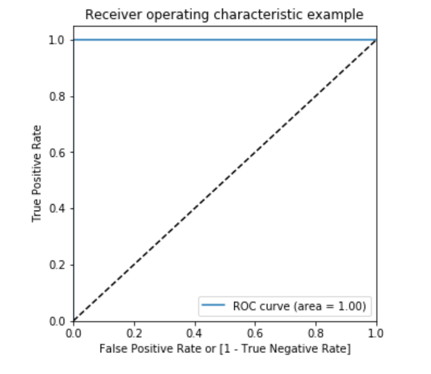

#### Prediction on the test set

*# Prediction on the test set*

y_test_pred **=** logistic_bal_adasyn_model**.**predict(X_test)

*# Confusion matrix*

confusion **=** metrics**.**confusion_matrix(y_test, y_test_pred)

print(confusion)

[[51642 5224]

[ 4 92]]

TP **=** confusion[1,1] *# true positive*

TN **=** confusion[0,0] *# true negatives*

FP **=** confusion[0,1] *# false positives*

FN **=** confusion[1,0] *# false negatives*

*# Accuracy*

print("Accuracy:-",metrics**.**accuracy_score(y_test, y_test_pred))

*# Sensitivity*

print("Sensitivity:-",TP **/** float(TP**+**FN))

*# Specificity*

print("Specificity:-", TN **/** float(TN**+**FP))

Accuracy:- 0.9082195147642288

Sensitivity:- 0.9583333333333334

Specificity:- 0.9081349136566665

*# classification_report*

print(classification_report(y_test, y_test_pred))

precision recall f1-score support

0 1.00 0.91 0.95 56866

1 0.02 0.96 0.03 96

accuracy 0.91 56962

macro avg 0.51 0.93 0.49 56962

weighted avg 1.00 0.91 0.95 56962

*# Predicted probability*

y_test_pred_proba **=** logistic_bal_adasyn_model**.**predict_proba(X_test)[:,1]

*# roc_auc*

auc **=** metrics**.**roc_auc_score(y_test, y_test_pred_proba)

auc

0.9671573487086602

*# Plot the ROC curve*

draw_roc(y_test, y_test_pred_proba)

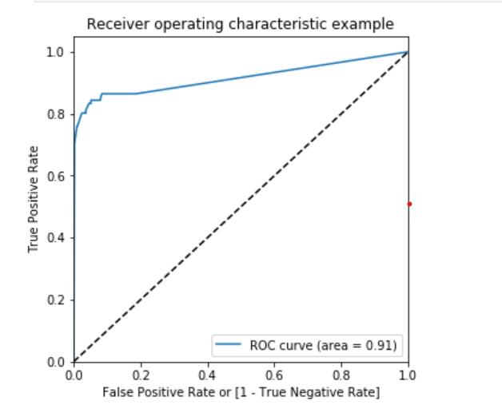

\***Model summary**\*

* Train set
  + Accuracy = 0.88
  + Sensitivity = 0.86
  + Specificity = 0.91
  + ROC = 0.96
* Test set
  + Accuracy = 0.90
  + Sensitivity = 0.95
  + Specificity = 0.90
  + ROC = 0.97

### Decision Tree

*# Create the parameter grid*

param_grid **=** {

'max_depth': range(5, 15, 5),

'min_samples_leaf': range(50, 150, 50),

'min_samples_split': range(50, 150, 50),

}

*# Instantiate the grid search model*

dtree **=** DecisionTreeClassifier()

grid_search **=** GridSearchCV(estimator **=** dtree,

param_grid **=** param_grid,

scoring**=** 'roc_auc',

cv **=** 3,

verbose **=** 1)

*# Fit the grid search to the data*

grid_search**.**fit(X_train_adasyn,y_train_adasyn)

Fitting 3 folds for each of 8 candidates, totalling 24 fits

[Parallel(n_jobs=1)]: Using backend SequentialBackend with 1 concurrent workers.

[Parallel(n_jobs=1)]: Done 24 out of 24 | elapsed: 5.4min finished

GridSearchCV(cv=3, error_score=nan,

estimator=DecisionTreeClassifier(ccp_alpha=0.0, class_weight=None,

criterion='gini', max_depth=None,

max_features=None,

max_leaf_nodes=None,

min_impurity_decrease=0.0,

min_impurity_split=None,

min_samples_leaf=1,

min_samples_split=2,

min_weight_fraction_leaf=0.0,

presort='deprecated',

random_state=None,

splitter='best'),

iid='deprecated', n_jobs=None,

param_grid={'max_depth': range(5, 15, 5),

'min_samples_leaf': range(50, 150, 50),

'min_samples_split': range pre_dispatch='2*n_jobs', refit=True, return_train_score=False,

scoring='roc_auc', verbose=1)

|  |  |  |  |  |  |  |  |  |  |  |  |  |  |  |
| --- | --- | --- | --- | --- | --- | --- | --- | --- | --- | --- | --- | --- | --- | --- |
|  |  |  |  |  |  |  |  |  |  |  |  |  |  |  |
|  |  |  |  |  |  |  |  |  |  |  |  |  |  |  |
|  |  |  |  |  |  |  |  |  |  |  |  |  |  |  |
|  |  |  |  |  |  |  |  |  |  |  |  |  |  |  |
|  |  |  |  |  |  |  |  |  |  |  |  |  |  |  |
|  |  |  |  |  |  |  |  |  |  |  |  |  |  |  |
|  |  |  |  |  |  |  |  |  |  |  |  |  |  |  |
|  |  |  |  |  |  |  |  |  |  |  |  |  |  |  |

*# cv results*

cv_results **=** pd**.**DataFrame(grid_search**.**cv_results_)

cv_results

*# Printing the optimal sensitivity score and hyperparameters*

print("Best roc_auc:-", grid_search**.**best_score_)

print(grid_search**.**best_estimator_)

Best roc_auc:- 0.9414793563319087

DecisionTreeClassifier(ccp_alpha=0.0, class_weight=None, criterion='gini',

max_depth=10, max_features=None, max_leaf_nodes=None,

min_impurity_decrease=0.0, min_impurity_split=None,

min_samples_leaf=100, min_samples_split=50,

min_weight_fraction_leaf=0.0, presort='deprecated',

random_state=None, splitter='best')

*# Model with optimal hyperparameters*

dt_bal_adasyn_model **=** DecisionTreeClassifier(criterion **=** "gini",

random_state **=** 100,

max_depth**=**10,

min_samples_leaf**=**100,

min_samples_split**=**50)

dt_bal_adasyn_model**.**fit(X_train_adasyn, y_train_adasyn)

DecisionTreeClassifier(ccp_alpha=0.0, class_weight=None, criterion='gini',

max_depth=10, max_features=None, max_leaf_nodes=None,

min_impurity_decrease=0.0, min_impurity_split=None,

min_samples_leaf=100, min_samples_split=50,

min_weight_fraction_leaf=0.0, presort='deprecated',

random_state=100, splitter='best')

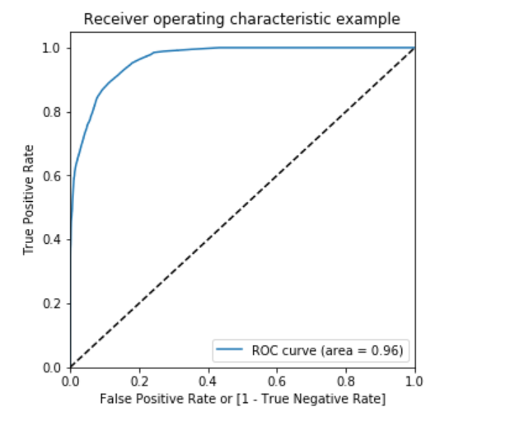

##### Prediction on the train set

*# Predictions on the train set*

y_train_pred **=** dt_bal_adasyn_model**.**predict(X_train_adasyn)

*# Confusion matrix*

confusion **=** metrics**.**confusion_matrix(y_train_adasyn, y_train_pred)

print(confusion)

[[215929 11520]

[ 1118 226330]]

TP **=** confusion[1,1] *# true positive*

TN **=** confusion[0,0] *# true negatives*

FP **=** confusion[0,1] *# false positives*

FN **=** confusion[1,0] *# false negatives*

*# Accuracy*

print("Accuracy:-",metrics**.**accuracy_score(y_train_adasyn, y_train_pred))

*# Sensitivity*

print("Sensitivity:-",TP **/** float(TP**+**FN))

*# Specificity*

print("Specificity:-", TN **/** float(TN**+**FP))

Accuracy:- 0.9722178866864367

Sensitivity:- 0.9950845907636031

Specificity:- 0.9493512831447929

*# classification_report*

print(classification_report(y_train_adasyn, y_train_pred))

precision recall f1-score support

0 0.99 0.95 0.97 227449

1 0.95 1.00 0.97 227448

accuracy 0.97 454897

macro avg 0.97 0.97 0.97 454897

weighted avg 0.97 0.97 0.97 454897

*# Predicted probability*

y_train_pred_proba **=** dt_bal_adasyn_model**.**predict_proba(X_train_adasyn)[:,1]

*# roc_auc*

auc **=** metrics**.**roc_auc_score(y_train_adasyn, y_train_pred_proba)

auc

0.9917591040224101

*# Plot the ROC curve*

draw_roc(y_train_adasyn, y_train_pred_proba)

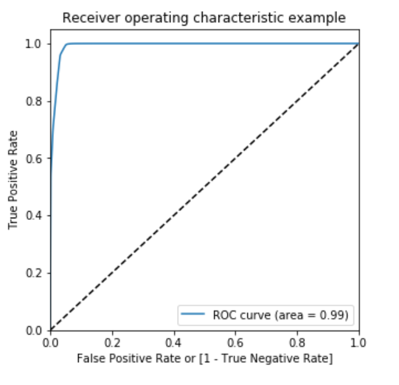

##### Prediction on the test set

*# Predictions on the test set*

y_test_pred **=** dt_bal_adasyn_model**.**predict(X_test)

*# Confusion matrix*

confusion **=** metrics**.**confusion_matrix(y_test, y_test_pred)

print(confusion)

[[53880 2986]

[ 15 81]]

TP **=** confusion[1,1] *# true positive*

TN **=** confusion[0,0] *# true negatives*

FP **=** confusion[0,1] *# false positives*

FN **=** confusion[1,0] *# false negatives*

*# Accuracy*

print("Accuracy:-",metrics**.**accuracy_score(y_test, y_test_pred))

*# Sensitivity*

print("Sensitivity:-",TP **/** float(TP**+**FN))

*# Specificity*

print("Specificity:-", TN **/** float(TN**+**FP))

Accuracy:- 0.9473157543625575

Sensitivity:- 0.84375

Specificity:- 0.9474905919178419

*# classification_report*

print(classification_report(y_test, y_test_pred))

precision recall f1-score support

0 1.00 0.95 0.97 56866

1 0.03 0.84 0.05 96

accuracy 0.95 56962

macro avg 0.51 0.90 0.51 56962

weighted avg 1.00 0.95 0.97 56962

*# Predicted probability*

y_test_pred_proba **=** dt_bal_adasyn_model**.**predict_proba(X_test)[:,1]

*# roc_auc*

auc **=** metrics**.**roc_auc_score(y_test, y_test_pred_proba)

auc

0.9141440147305362

*# Plot the ROC curve*

draw_roc(y_test, y_test_pred_proba)

\***Model summary**\*

* Train set
  + Accuracy = 0.97
  + Sensitivity = 0.99
  + Specificity = 0.95
  + ROC-AUC = 0.99
* Test set
  + Accuracy = 0.95
  + Sensitivity = 0.84
  + Specificity = 0.95
  + ROC-AUC = 0.91

### XGBoost

*# hyperparameter tuning with XGBoost*

*# creating a KFold object*

folds **=** 3

*# specify range of hyperparameters*

param_grid **=** {'learning_rate': [0.2, 0.6],

'subsample': [0.3, 0.6, 0.9]}

*# specify model*

xgb_model **=** XGBClassifier(max_depth**=**2, n_estimators**=**200)

*# set up GridSearchCV()*

model_cv **=** GridSearchCV(estimator **=** xgb_model,

param_grid **=** param_grid,

scoring**=** 'roc_auc',

cv **=** folds,

verbose **=** 1,

return_train_score**=True**)

*# fit the model*

model_cv**.**fit(X_train_adasyn, y_train_adasyn)

Fitting 3 folds for each of 6 candidates, totalling 18 fits

[Parallel(n_jobs=1)]: Using backend SequentialBackend with 1 concurrent workers.

[Parallel(n_jobs=1)]: Done 18 out of 18 | elapsed: 42.5min finished

GridSearchCV(cv=3, error_score=nan,

estimator=XGBClassifier(base_score=None, booster=None,

colsample_bylevel=None,

colsample_bynode=None,

colsample_bytree=None, gamma=None,

gpu_id=None, importance_type='gain',

interaction_constraints=None,

learning_rate=None, max_delta_step=None,

max_depth=2, min_child_weight=None,

missing=nan, monotone_constraints=None,

n_estimato...

objective='binary:logistic',

random_state=None, reg_alpha=None,

reg_lambda=None, scale_pos_weight=None,

subsample=None, tree_method=None,

validate_parameters=False,

verbosity=None),

iid='deprecated', n_jobs=None,

param_grid={'learning_rate': [0.2, 0.6],

'subsample': [0.3, 0.6, 0.9]},

pre_dispatch='2*n_jobs', refit=True, return_train_score=True,

scoring='roc_auc', verbose=1)

*# cv results*

cv_results **=** pd**.**DataFrame(model_cv**.**cv_results_)

cv_results

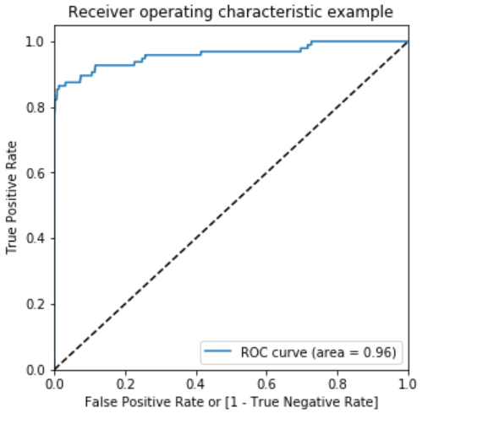

Model summary*

Train set

Accuracy = 0.99

Sensitivity = 1.0

Specificity = 1.0

ROC-AUC = 1.0

Test set

Accuracy = 0.99

Sensitivity = 0.78

Specificity = 0.99

ROC-AUC = 0.96

Choosing best model on the balanced data

He we balanced the data with various approach such as Undersampling, Oversampling, SMOTE and Adasy. With every data balancing thechnique we built several models such as Logistic, XGBoost, Decision Tree, and Random Forest.

We can see that almost all the models performed more or less good. But we should be interested in the best model.

Though the Undersampling technique models performed well, we should keep mind that by doing the undersampling some imformation were lost. Hence, it is better not to consider the undersampling models.

Whereas the SMOTE and Adasyn models performed well. Among those models the simplist model Logistic regression has ROC score 0.99 in the train set and 0.97 on the test set. We can consider the Logistic model as the best model to choose because of the easy interpretation of the models and also the resourse requirements to build the mdoel is lesser than the other heavy models such as Random forest or XGBoost.

Hence, we can conclude that the Logistic regression model with SMOTE is the best model for its simlicity and less resource requirement.

Print the FPR,TPR & select the best threshold from the roc curve for the best model

print('Train auc =', metrics.roc_auc_score(y_train_smote, y_train_pred_proba_log_bal_smote))

fpr, tpr, thresholds = metrics.roc_curve(y_train_smote, y_train_pred_proba_log_bal_smote)

threshold = thresholds[np.argmax(tpr-fpr)]

print("Threshold=",threshold)

Train auc = 0.9897539730968845

Threshold= 0.5311563613510013

We can see that the threshold is 0.53, for which the TPR is the highest and FPR is the lowest and we got the best ROC score.

## **Cost benefit analysis**

We have tried several models till now with both balanced and imbalanced data. We have noticed most of the models have performed more or less well in terms of ROC score, Precision and Recall.

But while picking the best model we should consider few things such as whether we have required infrastructure, resources or computational power to run the model or not. For the models such as Random forest, SVM, XGBoost we require heavy computational resources and eventually to build that infrastructure the cost of deploying the model increases. On the other hand the simpler model such as Logistic regression requires less computational resources, so the cost of building the model is less.

We also have to consider that for little change of the ROC score how much monetary loss of gain the bank incur. If the amount if huge then we have to consider building the complex model even though the cost of building the model is high.

## **Summary to the business**

For banks with smaller average transaction value, we would want high precision because we only want to label relevant transactions as fraudulent. For every transaction that is flagged as fraudulent, we can add the human element to verify whether the transaction was done by calling the customer. However, when precision is low, such tasks are a burden because the human element has to be increased.

For banks having a larger transaction value, if the recall is low, i.e., it is unable to detect transactions that are labelled as non-fraudulent. So we have to consider the losses if the missed transaction was a high-value fraudulent one.

So here, to save the banks from high-value fraudulent transactions, we have to focus on a high recall in order to detect actual fraudulent transactions.

After performing several models, we have seen that in the balanced dataset with SMOTE technique the simplest Logistic regression model has good ROC score and also high Recall. Hence, we can go with the logistic model here. It is also easier to interpret and explain to the business.